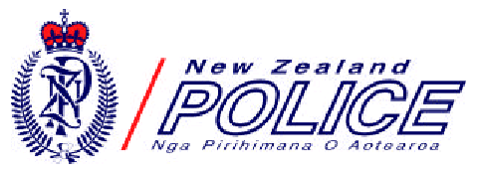

Safer Communities Together

Community Roadwatch Report

This report will be used by the New Zealand Police to advise the owner of a motor vehicle
about the driving behaviour you have observed and reported. The Police will regard your
report as confidential; in accordance with the provisions of the law as it relates to privacy
and disclosure of information.

What did you see?
[please tick an option]

○ A driver overtaking on ‘ no passing lines’
○ A driver overtaking in the face of oncoming traffic causing another driver to take evasive action
○ A driver crossing the centre line on bends in the road
○ A driver following too close (tailgating) behind your vehicle or another vehicle
○ A slow driver holding up traffic and not making allowance for others to pass
○ Other dangerous driving behaviour (please make brief notes about what you saw happening)

When and where?
Date: ………../………../……….. Time ………..………..am/pm
Location:
(please write the name of the road or common landmark)
Nearest city/town:

Details of the offending vehicle
Registration number Make: Colour:
Information about other passengers (please tick one) Driver only ○ Family group ○ Other passengers ○

Your details please
Title: Mr / Mrs / Ms / Miss (circle one) Name:
Address:

Registration number of your vehicle Your telephone number: (….)
Please sign here:
Post this form to: NZ Police, Community Roadwatch, PO Box 27304, Wellington. Or deliver it to your nearest Police Station.
Official use only
Prec Code:....................
Location:.......................
Status:...........................

