

PO Box 6491 Auckland

Chairperson: Jane Dawson

Ph: 04-385-2557

Email: dawbell@actrix.gen.nz

Secretary: Adrian Croucher
Ph: 09-373-7599 ext 4611

Email: secretary@can.org.nz
www.can.org.nz

LOCAL CONTACTS

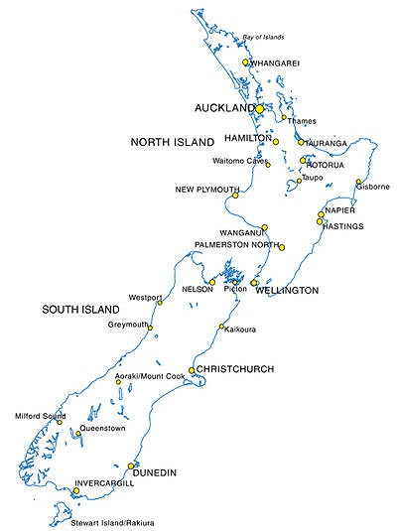
OTHER LOCAL CONTACTS:
Kerikeri: Molly Hamilton, Ph: 09-407 8342
Whangarei: Shane Jansen, Ph: 09-436 2854
Rotorua: Tim Fletcher, Ph: 07-357 4851
Taupo: David Wigley, Ph: 07-378-2011
Napier: Ian McLean, Ph: 06-843 7157, Email: imclean@clear.net.nz
Hastings: Max Neumegen, Ph: 06-873-0267,
Email: mxn@paradise.net.nz
Dannevirke: Ross Abbott, Ph: 06-374-8645 (a/h)
Inglewood: William Orpin, Ph: 06-756 5507
Wanganui: Kerry Wood, Ph: 06-347 2387, 021-115 9346,
Email: kerry.wood@paradise.net.nz
Picton: Peter Bugler, Ph: 03-573 6685, Email: buglers@xtra.co.nz
Takaka: Paul Woodward, Ph: 03-525 7233,
Email: pwoodward@xtra.co.nz
Pleasant Point: Bill Wright, Ph: 03-614 7702,
Email: gwright@voyager.co.nz

AKLD CYCLE TOURING ASSN

Contact: John Gregory
13 Buckley Road, Epsom, Akld
Ph: 09-525-6508
Email: gregory@buckley.pl.net

CYCLE ACTION AUCKLAND

Contact: Adrian Croucher

PO Box 6491, Auckland
Ph: 09-373-7599 ext 4611
Email: can@actrix.gen.nz

CYCLE ACTION WAIKATO

Contact: Rob Davidson/Chris McGovern
PO Box 19-251, Hamilton
Ph: 07-856-5217
Email: rob.davidson@actrix.co.nz

CYCLE ACTION TAURANGA

Contact: Iris Thomas
PO Box 2523, Tauranga
Ph: 07-544-2609
Email: comsport@xtra.co.nz

CYCLE AWARE PALM.NTH

Contact: Bob Lambourne

PO Box 961, Palmerston North

Ph: 06-350-5799 ext2816

Email: capn@bikerider.com

KAPITI CYCLING INC

Contact: Liz Mikkelsen

Ph: 06-364-8187
Email: kapiticycling@xtra.co.nz

CYCLE AWARE WELLINGTON INC

Contact: Alan Whiting

PO Box 11-964, Wellington

Ph: 04-384-2201

Email: alanwhiting@ paradise.net.nz

BICYCLE NELSON BAYS

Contact: Iain Dephoff
PO Box 685, Nelson
Ph: 03-543-3639
Email: depwell@ts.co.nz

SPOKES CHRISTCHURCH

Contact: Richard Hayman

PO Box 4536, Christchurch

Ph: 03-379-9174

Email: Spokes_chch@ hotmail.com

SPOKES DUNEDIN

Contact: Liz Crook

PO Box 6321 Dunedin North

Ph: 03-466-7800

Email: Liz@khealthotago.co.nz
BIKE LANES IN PARADISE (BLIP)
Contact: Victoria Davis

PO Box 92, Takaka
Ph: 03-525-9298
Email: moonbowbeach@hotmail.com

