Windy Wheels
22nd February 2009
Being the news and views letter of Cycle Aware Wellington.

Frocks on Bikes
This is an initiative to promote women on bikes wearing everyday clothes and/or glamorous frocks/dresses etc., with the aim of helping to normalise cycling, especially for short trips, in work clothes. Ultimately, it hopes to encourage a culture more like the European one, with biking for everyone in their everyday clothes and/or frocks/high heels etc.!!

Louise Thornley and colleague Jude are co-ordinating this in the Wellington area. They had some funding from CAN’s Walking and Cycling Micro-Fund to run lunchtime women's bike rides during February, and to undertake associated publicity. These have been very successful and the rides will continue in the future. They will also be running Cycle Maintenance workshops for women – watch this space!

An internet group has been set up, through the ‘Intersect’ website, so feel free to join this or read the discussion...there seems to be a large amount of interest and enthusiasm for the concept!

See: http://intersect.ning.com/group/frocksonbikes , http://www.frocksonbikes.org, and also http://caw.org.nz/event/frocks-on-bikes-frocknic-wairarapa-ride

Wellington Long Term Council Community Plan (LTCCP)
Wellington City Council is currently reviewing its Long Term Council Community Plan and various CAW members have represented cyclists’ interests at a variety of early stakeholder engagement meetings held in February. The main thrust for the Council is the need to contain rate rises within a 4% threshold, and therefore discussing which services can be reduced or modified to be able to achieve this.

Currently the Council is producing a draft LTCCP, and you are still able to have some input, although the more formal consultation period finished on the 20 February. To have your say please visit the Council’s website http://www.wellingtonlongtermplan.co.nz/

Have your say on the discussion board…. http://www.wellingtonlongtermplan.co.nz/TRANSPORT or you can even join the Facebook group!

CAW’s representatives stressed the importance of:
- Ensuring commitment to, and continued funding for, cycle policy.
- Active transport all the more important in time of recession.
- The Great Harbour Way – including maintaining and improving cycle facilities around the harbour
- New initiatives should include consideration of cycling possibilities/implications

So get typing and let the Council know how important it is that active transport is improved and promoted in times of recession….mainly because it makes everyone happy, fit and healthy – very important when your (or the Council’s) bank account is looking a bit grim!

Cycle training for women
CAW members Lou and Marilyn are teaming up to provide cycle training for Frocks on Bikes riders (www.frocksonbikes.org), through Bikeability Cycle Training. Bikeability is CAN's brand for cycle skills training. All training is based on the NZ Cycle Training Guidelines (http://can.org.nz/cycle-training).

There are two different workshops offered. The first of the workshops has already taken place, but it’s included here so you can see what wonderful work they’re doing.
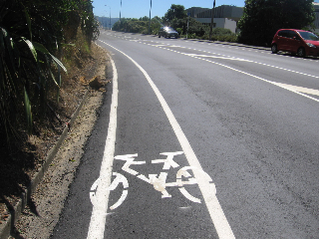
Evan’s Bay cycle lane
1. Two 60-minute Commuter Cyclist Workshops for Women
The workshops cover safe riding tips, road rules, maps, equipment, accessories, cycling groups and where to go for more info.

When: Mon 23 Feb, 12-1; and 5:30-6:30
Where: WCC meeting room 2
Who: up to 30 participants
How much: free to participants.

2. A 3-hour practical Cycle Training Workshop for Women
Each instructor can take 6 trainees for the on-road activities. Skills taught include starting an on-road journey, passing parked cars, intersection drills, shoulder checking, emergency braking,
risk management and journey planning.

When: Sat 28 Feb 1-4pm
Where: car park beside the Kilbirnie Aquatic Centre hydrotherapy pool
Who: up to 18 trainees
How much: $20 cost to participants.

Enquires: northgalt@paradise.net.nz

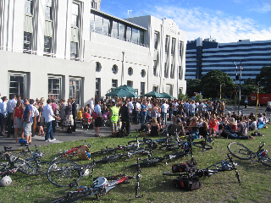
Critical Mass
Critical Mass stops for refreshments, 30 January 2009
There are moves afoot to re-invigorate Critical Mass in Wellington. If any of you have been on a CM ride overseas (or on the recent Frocks on Bikes street ride) you’ll know how much fun it can be… and CM also sends a message to the powers that be about the groundswell of cyclists who want a safe and sustainable city. http://criticalmass.org.nz/index.php?id=43

Great Harbour Way
For those that don’t know, the Great Harbour Way is an exciting initiative to create a cycling and walking route right around Wellington Harbour, from Red Rocks in Island Bay around to Pencarrow Head beyond Eastbourne. (see http://www.greatharbourway.org.nz/ for more info)

There is a good deal of support for this, from user groups through community groups to politicians (eg. Peter Dunne) and councils. It was even mentioned in a politician’s maiden speech in parliament! Some money had been promised for a feasibility report.

The stretch from Petone to Ngauranga, arguably the most urgent and important, is proving to be the most difficult, with agencies saying that nothing can be done here for cyclists until the ‘Triangle’ study has been completed (the area within the triangle of Ngauranga, Grenada and Petone). This study is now progressing, and we can hope for some movement here.

Bicycle User Groups (BUGs)
Bicycle User Groups are groups set up within a work-place to give cycling a voice within the organisation. Members of the group may work together to improve facilities for cyclists in the workplace, encourage workmates to cycle to work, lobby on local or national cycling issues, arrange social rides etc. If you are interested in setting a BUG up in your workplace, or are interested in helping to promote these around the city, contact Robert Ibell: robert@can.org.nz (and see http://caw.org.nz/node/1933)

New Zealand Cycling Conference
New Plymouth has been confirmed as the venue for the 7th New Zealand Cycling Conference. The conference will be held on 12 & 13 November 2009 (Thursday & Friday).

The conference will be preceded by a meeting of the Australian Bicycle Council (ABC) on Wednesday, 10 November 2009. On the weekend following the conference (13 & 14 November 2009), CAN will hold its annual CAN Do.

A call for papers will be made in March 2009. Conference registrations will commence in July 2009.

See http://can.org.nz/node/3141

Planning Meeting
At the last CAW meeting it was suggested that we had another planning meeting, in which to formulate and prioritise an action plan for the group for 2009 and beyond. If you are interested in being part of this, and/or have ideas for inclusion, please contact Illona (contact details below).

Next Meeting
CAW meetings are held regularly on the 1st Tuesday of the Month at the Southern Cross Tavern, corner Cuba and Abel Smith Sts. The next meeting will on Tuesday 3rd March from 6:00pm to 7:30pm.

Contacts
Cycle Aware Wellington (CAW), website: http://cms.caw.org.nz/ (present address for new site) or www.caw.org.nz; email: info@caw.org.nz; postal: PO Box 27120, Wellington.
Chair: Illona Keenan, email: illona.keenan@gmail.com
Secretary: Alastair Smith, email: Alastair.Smith@vuw.ac.nz, phone: 04 463-5785
Membership: Teresa Maguire, email: laingmaguire@paradise.net.nz, phone: 04 9711 505
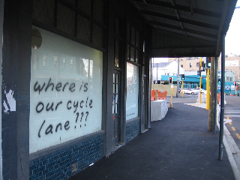
Cycling Advocates’ Network (CAN): website: www.can.org.nz, email: patrick@can.org.nz (Wgtn office), secretary@can.org.nz, phone: 04 3854 967, postal: PO Box 6491, Auckland.
A Riddiford Street shop window

