Windy Wheels
20th April 2009
Being the news and views letter of Cycle Aware Wellington.

Long Term Council Community Plan (LTCCP) (for 2009 – 2019)
You still have a few days in which to male a written submission on the Long Term Council Community Plans for the region’s city councils: Wellington (by 18th May), Hutt City (30th April), Porirua City (1st May), Upper Hutt (13th May).

In the drafting meeting, CAW’s representatives stressed the importance of:
- Ensuring commitment to, and continued funding for, cycle policy;
- Promoting active transport - all the more important in time of recession;
- Supporting The Great Harbour Way – including maintaining and improving cycle facilities around the harbour;
- That new initiatives should include consideration of cycling possibilities/implications.

Please try and find time to make a submission, even if only short. This is a good opportunity to encourage improved local-body commitment to cycling, at a time when councils seem keen to pull back on cycling initiatives with the excuse of the current economic environment.

For more information, including dates for oral submissions and links for online questionnaires, see: http://can.org.nz/article/submissions-for-2009

Botanical Gardens cycle path
Recently the Wellington City Council commissioned an independent assessment of cycling in the Cable Car Prescient of the Botanical Gardens by Tourism Resource Consultants (TRCNZ). This is to attempt to reach a compromise with cyclists, who are keen to use paths within the Gardens in their daily commute - particularly the Upland Road to Salamanca Road route – which are presently forbidden to cyclists.

A public meeting was held in March this year, attended by CAW members, producing useful ideas and positive suggestions for ways forward. TRCNZ’s report is undergoing final revisions and will be released shortly.

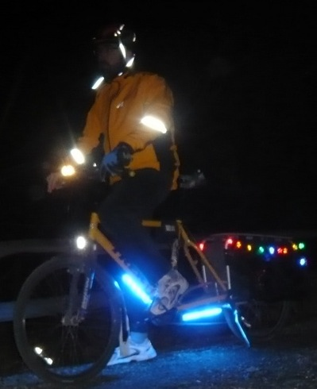
Light up for winter
With the clocks now back, and winter approaching, all cyclists should light up and brighten up. Cycling Advocates' Network (CAN) spokes person Stephen McKernon says, “Cyclists should light up for morning, evening, and bad weather riding. Cycling fatalities have declined over recent years, at the same time as high-visibility riding gear and brighter lights have become more popular. Safety-focused attitudes and good safety equipment work."
CAN strongly recommends high-visibility reflective gear such as fluorescent clothing, pack covers, and extra reflectors. "The use of high-visibility gear and stronger lights has become more popular over the last decade," McKernon says.
"We suspect this may be why cycling fatalities have declined since 1998. Bike sales are up, our roads are busier, and cycling accidents have increased, but brighter cyclists are far less vulnerable at night, which can be the most dangerous time for sharing the roads".
The NZ Road Code says that bikes and cyclists out at night must have:
- a steady or flashing rear-facing red light
- a steady or flashing forward-facing white light
- a rear reflector on the bike
- reflectors on pedals, or reflective clothing.

"And have a bicycle bell or horn," adds Mr. McKernon "Use it to let cars and pedestrians know where you are!"

New Zealand Cycling Conference
New Plymouth has been confirmed as the venue for the 7th New Zealand Cycling Conference. The conference will be held on 12 & 13 November 2009 (Thursday & Friday). The theme for this year is “Communities, connections and the economy”

A meeting of the Australian Bicycle Council (ABC) on Wednesday, 11th November 2009 will precede the conference. On the weekend following the conference (14th & 15th November 2009), CAN will hold its annual CAN Do, also in New Plymouth.

A call for papers will be made in later this month. Conference registrations will commence in June 2009.

See http://can.org.nz/node/3141 for more and links to info on previous conferences.

Frocks on Bikes
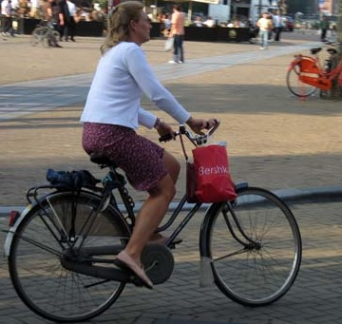
Frocks on Bikes have been continuing their promoting of women riding bikes without having to ‘lycra-up’, encouraging women to wear everyday, or even glamorous, frocks and dresses for their daily commute or pleasure ride.
Woman cyclist in Amsterdam

One of their latest initiatives was a 40km ride in the Wairarapa countryside, with a café stop at Carterton, wine tasting at Gladstone, and a picnic at Carter’s Bush. Tranz Metro put on an extra carriage in order to carry the bikes. Enjoyed by all, both frocked and un-frocked.

For more information on Frocks on Bikes, see: http://www.frocksonbikes.org

Next Meeting - AGM
CAW meetings are held regularly on the 1st Tuesday of the Month at the Southern Cross Tavern, corner Cuba and Abel Smith Sts. The next meeting will on Tuesday 5th May from 6:00pm to 7:30pm, and will be the organisation’s Annual General Meeting. The agenda to date is:

- Attendance and apologies
- Approval of minutes from 2008 AGM
- Matters arising from minutes
- Consideration and adoption of Annual Report and Annual Accounts
- Election of Officers
- General Business

Then, after all the formal bits, we will have a guest speaker (to be confirmed) to talk about the proposed national cycle way. Exciting Stuff!

Please come along and help make CAW strong and active in the coming year. Last year’s was really well attended, and actually good fun!

Contacts
Cycle Aware Wellington (CAW), website: http://cms.caw.org.nz/ (present address for new site) or www.caw.org.nz; email: info@caw.org.nz; postal: PO Box 27120, Wellington.
Chair: Illona Keenan, email: illona@can.org.nz
Secretary: Alastair Smith, email: Alastair.Smith@vuw.ac.nz, phone: 04 463-5785
Membership: Teresa Maguire, email: laingmaguire@paradise.net.nz, phone: 04 9711 505
Cycling Advocates’ Network (CAN): website: www.can.org.nz, email: patrick@can.org.nz (Wgtn office), secretary@can.org.nz, phone: 04 3854 967, postal: PO Box 6491, Auckland.

