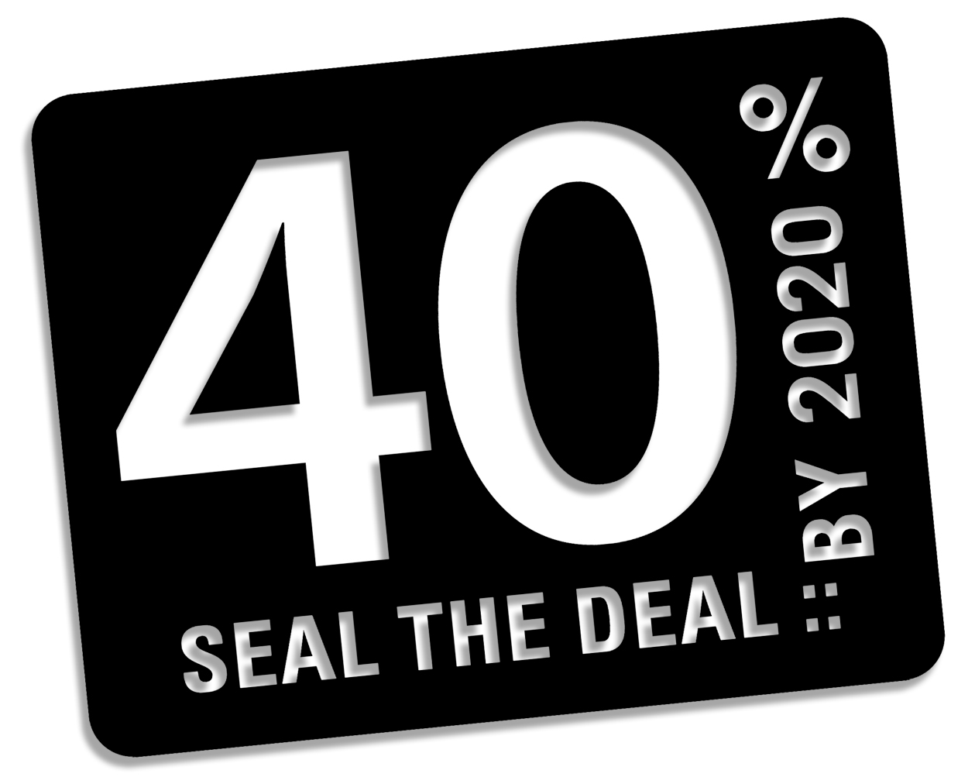
Climate Action Campaign, Sign Online at www.nec.org
In August the New Zealand Government will announce their short term target carbon emission reductions, which will be taken to the UN Climate Change Summit in Copenhagen (COP15) in December 2009.
We need our government to agree to a 40% reduction in these emissions below 1990 levels by 2020.
The Government will hold a public consultation in July and we want to ensure Nelson’s voice is heard.
Did you know...?
- Climate change is occurring at an unprecedented rate, faster than previous scientific predictions.
- Global carbon emission reduction targets will be agreed upon at the UN Climate Change Summit in December. This is our last chance to avoid runaway climate change.
- Scientific research points to a global 40% carbon emission reduction below 1990 levels as a minimum requirement to prevent catastrophic consequences.
- New Zealand is, per capita, among the worst greenhouse gas emitters in the world, at 18 Tonnes CO₂equivalent/person/yr. This is a huge contradiction to our clean and green image.
- Climate change is already adversely affecting New Zealand’s economy. In 2008 the drought in the Waikato cost the farming sector over NZ$1.24 billion (MAF).
- It is simply more cost effective to act now than delay. The 2006 Stern Review: The Economics of Climate Change states “the costs of action ... can be limited to around 1% of GDP each year; failure to take action could reduce GDP by 20% or more.”
It is imperative that the New Zealand Government takes significant action and this action needs to be taken sooner rather than later. The UN Climate Change Summit in December is hailed to be our last chance to reach a solution to prevent catastrophic climate change ‘tipping points’. Greenhouse gas emissions must be stabilised by 2015...in order to do this the International Community has to be on board, and that includes
New Zealand.
“I've said before that in order to solve the climate crisis, we can't just change light bulbs -- we need to change laws.” Al Gore, former US Vice President.
How you can help…
The Nelson Environment Centre is running a campaign in July 2009 to ensure our voice is heard. We will be hosting a number of events and running a petition asking the Government to set a 40% reduction in greenhouse gas emissions, which will be presented to Nick Smith, Nelson’s Local MP, and the Government’s Minister for the Environment, in late July.
We need volunteers to help run our events and collect signatures. Please do not hesitate to contact us if you would like to participate. Contact Hannah at NEC on 03 545 9176 or hannahnorbury@nec.org.nz
Climate Action Campaign Events’ Calendar

June 30th Nelson Environment Centre AGM
The Boat House, 7.30pm, Guest Speaker Dr Ed Kiddle:
“Climate Change, Cuts and Copenhagen 09”

July 4th Campaign Launch
Montgomery Square, 11am

July 16th-23rd Display at Elma Turner Library, Nelson

July 17th Government Road Show
Waimea Room, Rutherford Hotel, 7.30 – 9.00pm

July 18th ‘Age of Stupid’ Film Preview Exclusive!
Annesbrook Community Centre, 7.30pm
Tickets available from:
Nelson - Page and Blackmore, Sprig & Fern Hardy St & Pomeroy’s in Nelson. Richmond – Paper Plus in Richmond Mall & Sprig & Fern Queen St

Late July Late July Climate Action Campaign Closing Event & Petition Presentation to Nick Smith

July 31st – August 9th Environmental Film Festival The Suter Theatre

August 15/16th Ecofest Trafalgar Centre

September 20-26th United Nations Environment Programme – Seal the Deal – Climate Week

September 21st GCCA Global Day of Action

September 26/27th NEC Parliamentary Rugby and Netball Fundraiser and Debate

October 24th 350.org Day of Action

November 28th: COP Day of Action
Greenpeace March

December 7-18th UN Climate Change Summit, Copenhagen

December 12th International Day of Action

We need volunteers to help run our events and collect signatures. Come along to these events and sign our petition.
Look out for our petition on Saturdays in Montgomery Square next to the Saturday Market and at venues across the region.

