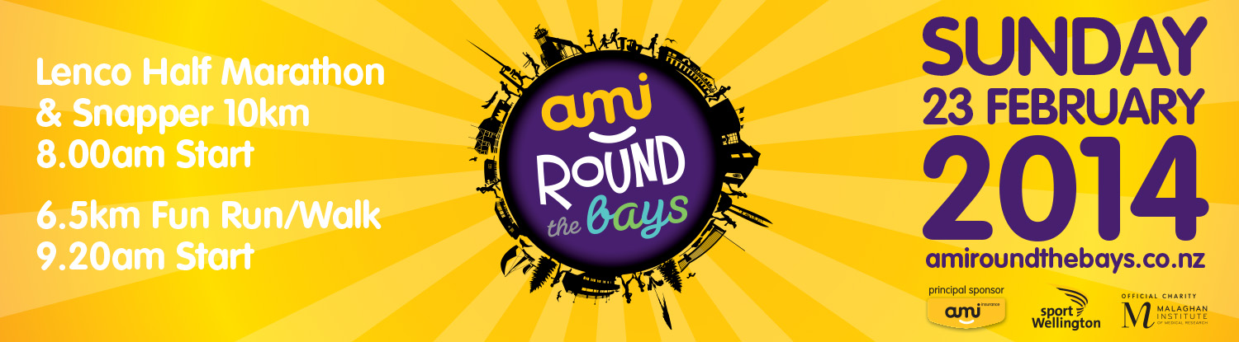

To whom it may concern,

As you may know we are only a few weeks away from this year’s AMI Round the Bays and because we are aware that there is a possibility it can cause you some inconvenience we want to give you some more information about the event so your service providers, staff and customers understand what will be going on, especially regarding the road closures.

AMI Round the Bays is organised by Sport Wellington, and the Official Charity Partner is the Malaghan Institute of Medical Research. Participants can raise funds to help the Malaghan find a cure for cancer, MS, Asthma and other diseases.

Held on Sunday February 23rd, 2014, the event has seen consecutive sell outs and around 14,000 participants are expected this year. There are three distance options involved – 6.5km fun run, walk and wheelchair option, as well as the Snapper 10km and Lenco Half Marathon. It will begin on Jervois Quay (opposite Frank Kitts Park), follow along Cable Street onto Oriental Parade, continuing around the bays to Evans Bay, and finishing at Kilbirnie Park. There will be multiple road closures taking place on the day, beginning around 6.30am. The race is due to start at 8am with the intention of competitors being off the roads early enough for there to be minimal impact on traffic.

All the information you need to know about the event can be found on our website – amiroundthebays.co.nz, so please check it out. You will also find attached to this letter a copy of our road closure information. Make sure to use South Coast Roads if travelling to or from the Eastern Suburbs or the Airport.

We would appreciate if you can let your members and customers know about the road closures by putting this information on your website or contacting them directly so everyone can familiarise with the multiple road closures.
If you have any concerns or wish to discuss matters relating to this event, please contact the On Course Assistant – Melvin Worth on roundthebays2@sportwellington.org.nz.

Kind regards,
James King
Business Manager
Sport Wellington
Level 2, 113 Adelaide Road | Newtown | PO Box 24-148 Manners St | Wellington
DDI: 04 389 0239| Mobile 027 242 2417
Email: jamesk@sportwellington.org.nz |Website: www.sportwellington.org.nz

AMI Round the Bays Road Closures
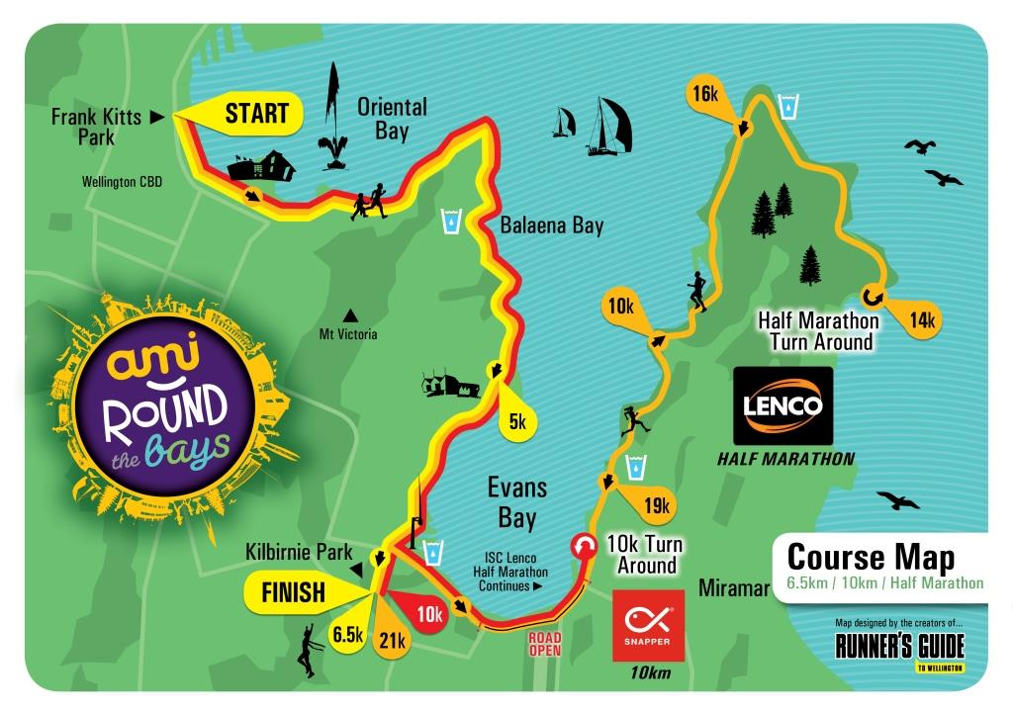

Police enforced Road Closures to all traffic including cyclists

City End

Customhouse Quay – Southbound lanes, Whitmore Street to Jervois Quay, from 6.30am to 11am
Jervois Quay – Southbound lanes, Customhouse Quay to Cable Street, from 6.30am to 11am
Cable Street –Jervois Quay to Oriental Parade, from 7am to 11am (right-hand lane open from Chaffers Street to Kent Terrace)
Oriental Parade – All, from 7.45am to 11am
(NB. All roads linking to Oriental Parade will also be closed from 7.45am to 11am)
Evans Bay Parade - Oriental Parade to Cobham Drive 7.45am to 12noon
(NB. All roads linking to Evans Bay Parade will also be closed 7.45am to 12noon)

Hataitai

No entry into Hataitai from corner of Taurima and Ruahine Street from 8am to 11.30am
(NB. Traffic can exit from Hataitai)
No entry into Hataitai from Goa Street from 8am to 11.30am
(NB. Traffic can exit from Hataitai)

Kilbirnie
Cobham Drive/Wellington Road – Full closure from Troy Street roundabout to Hamilton Road 8am to 11.30am
Cobham Drive – Eastbound, one lane closed between Troy Street and Calabar Road, 8am to 11.30am

A detour will be in place for State Highway One along Kilbirnie Crescent. Expect delays.

Evans Bay Parade –Cobham Drive to Kilbirnie Crescent, from 8am to 1pm
No exit from Kemp Street onto Evans Bay Parade 8am to 1pm
No access to Wellington Road from Crawford Road from 8am to 11.30am

Shelly Bay Road/Massey Road

A full road closure of Shelly Bay Road (Miramar Avenue intersection to Massey Road), 8am to 12noon
Massey Road to Scorching Bay Domain, 8am to 12 noon

No parking

Jervois Quay (Grey Street to Cable Street) 6.30am-11am
Cable Street – All (Jervois Quay to Oriental Parade) 6.30am-11am
Evans Bay Parade (Cobham Drive to Kemp Street) 6.30am-1pm
Kilbirnie Crescent (park side only) (Wellington Road to Evans Bay Parade) 6.30am-1pm

