I am writing this article as a member of Cycle Aware Wellington (although I am also a member of the architecture centre as well and this does have an architectural angle). Cycle Aware Wellington (CAW) is a cycle advocacy group, part of the national body Cycle Advocates Network (CAN).
CAW seeks to promote cycling (Bike to Work Day is 7-9am Wednesday 16th February, Queens Wharf under the sails http://can.org.nz/event/2011/02/16/go-by-bike-day-wellington) and advocate for better facilities for cycling in Wellington.
Being a cycle advocate has been a bit of a souless task. As it tends to be hard going CAW tends to pick key priorities. Thorndon Quay has been a priority for many years as by far the worst black spot for Cyclist (bloody angle parking) and now finally it is being improved. One of the next priorities is improving cycling on Jervios Quay.
This is important as there have been issues with cycling mixing with pedestrians on the waterfront. There are several tight spots. We have worked with Wellington Waterfront, helped run education programmes but the waterfront is probably never going to be suitable for fast commuting. Jervios Quay is a almost a motorway with 3 lanes both ways, little or no verges and an average speed of cars at 70km/h. Someone told me this issue is about voids and Jervios Quay must be a type of urban void. There is even an architecture practice down there called Void.
This all reminded me about going to a talk by Jan Gehl about 6-7 years ago. I like Jan Gehl. He talks about cycling a lot (somehow to me cycling and architecture were always somehow the same sort of thing) amongst other things. In fact in a recent interview http://sustainablecities.dk/en/actions/interviews/jan-gehl-making-healthy-cities he said that “This could mark the beginning of a century of bicycling”. Apparently he has also talked about walking at some stage.
The main point of his talk was that Jervios Quay stopped connections from the CPD to the waterfront. This was not rocket science, I had heard that a lot but I really liked his solution (maybe not rocket science either) was not more bridges (I once saw a picture of putting a Picton Ferry across Jervios in the paper) but reducing the lanes of traffic and make a boulevard with trees and space for people . It would be safe to cycle, it would be safe to walk across. I thought it was brilliant. I told my friends – they all thought it was daft.
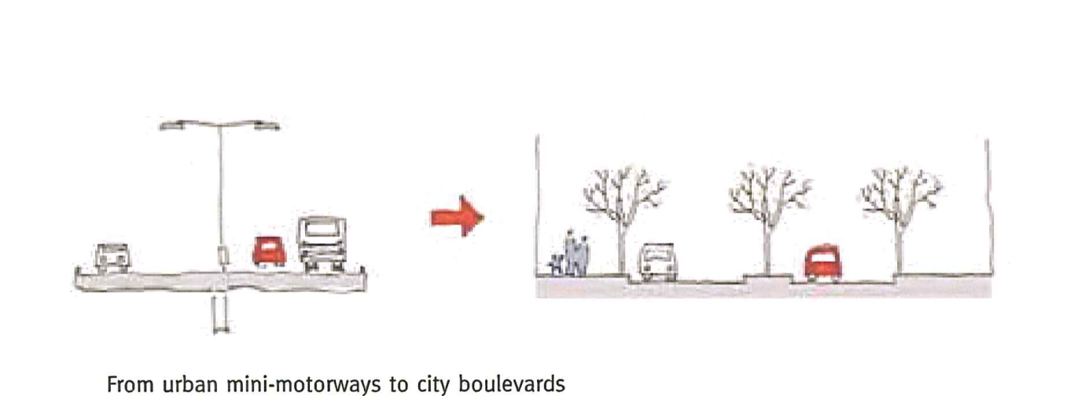
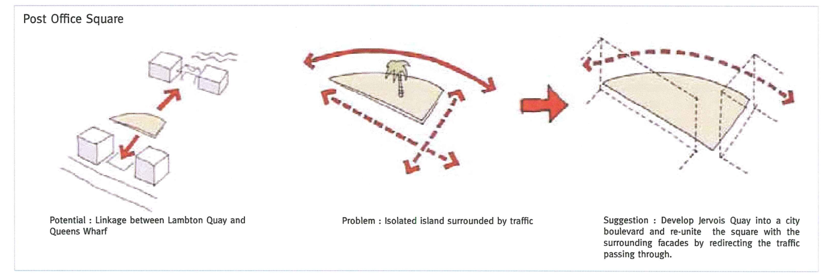
It was recommended in his the report to the council, http://www.wellington.govt.nz/services/urban/citytowaterfront/gehlreportindex.html , but it was soon rejected and forgotten.
Maybe things are changing. Different mayor, petrol prices going up. Maybe the idea can get a second chance. We often work with other groups such as Living Street Aotearoa. Maybe the Architecture Centre would be interested in working with us too.

