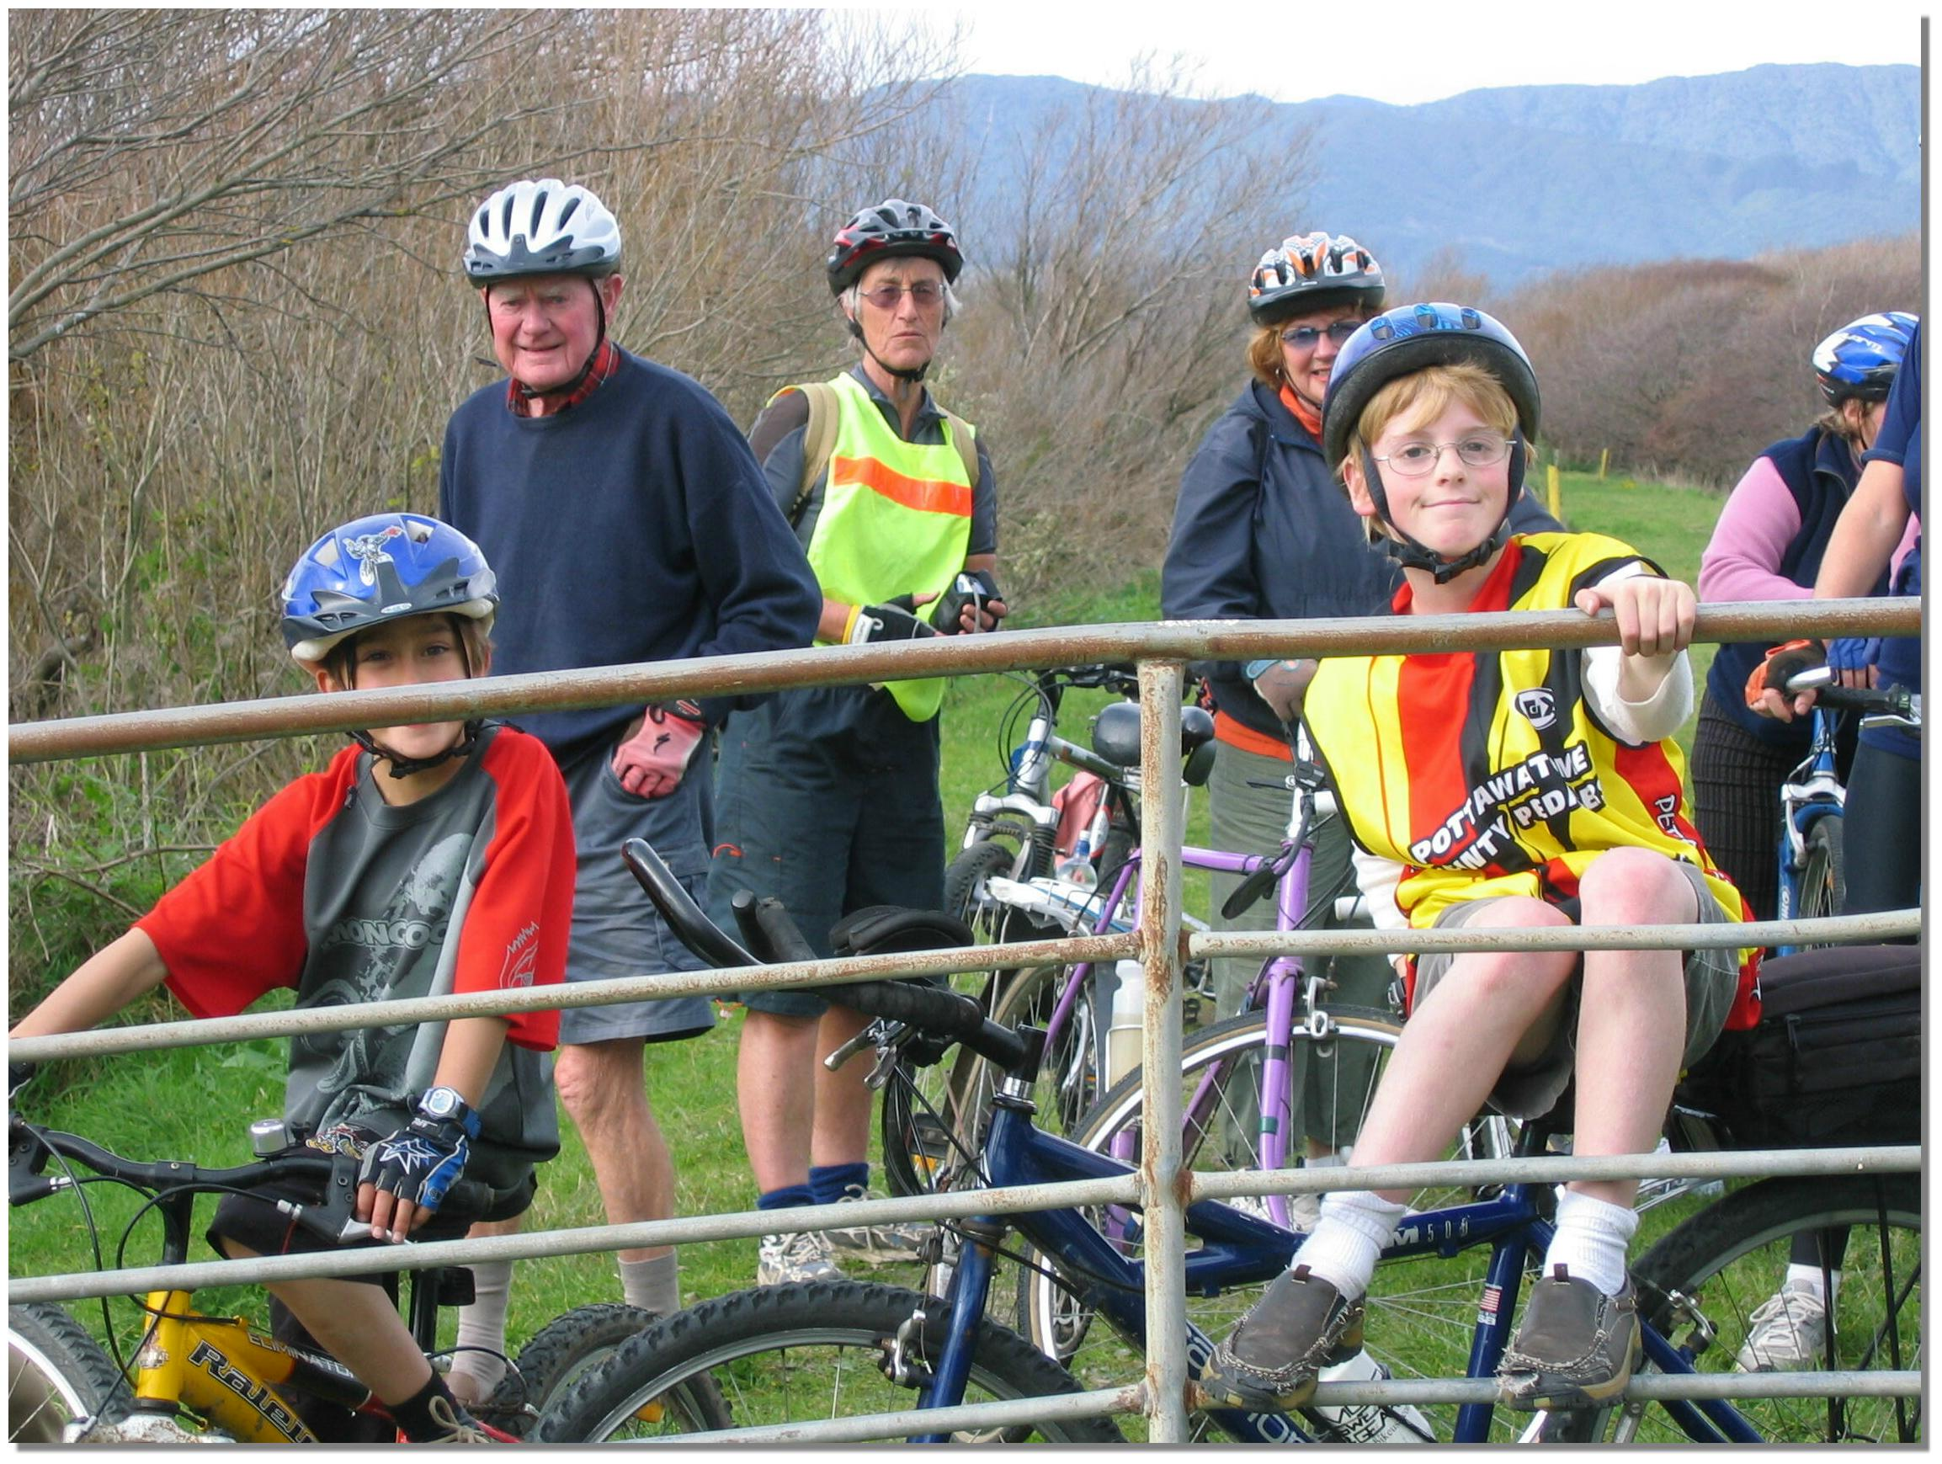
Otaki Cycling Environment & Access Network (OCEAN)
C/- Harry Hall
31 Mountainview Road
Otaki 5512

Removing barriers to cycling

2 May 2009

Wellington Regional Council
PO Box 11-646
WELLINGTON

Attention: Paul Bruce, Wellington Regional Councillor & member Transport and Access Committee, WRC.

GATES AT ENTRANCE TO THE SOUTHERN RIVERBANK – OTAKI RIVER

OCEAN was the forerunner to Kapiti Cycling Inc. The group formed in Otaki in 1999 for the purpose of advocating for long distance cycling connections between Paekakariki to North of Otaki eventually reaching Palmerston North. A proposal and petition with 900 signatures was presented to Kapiti Coast District Council in December 1999. On 26th August 2002 the group changed its name to Kapiti Cycling and became incorporated. The original group has now re-formed to work solely for cycle access off SH1 between Peka Peka and Otaki and North.

Kapiti Cycling Inc wrote a letter to Regional Councillor Chris Turver on 17th September 2005.The letter asked that cyclists be allowed access to the South bank of the Otaki River. We suggested specially designed gates and fences (as are used along the Otago Rail Trail and on similar Hawkes Bay tracks). We were met with a refusal to even consider cyclists having access to the South side of the river bank for picnics and enjoyment. We spoke about this problem again in May 2006 at the hearing for the Regional Cycling Strategy.

There is already a smooth 4WD track on the Stop Bank, walkers can scale the gates but cyclists have to lift their bikes over the gate that cross the pathway. The area is a beautiful picnic area with old trees in a parkland setting and lovely views of the river to the sea. We believe that since walkers are allowed on the River Bank and the land is public land, the Regional Council should erect gates that will allow cyclists to enjoy this ride. There are few places in Otaki proper where families can enjoy riding off-road in safety from motor vehicles.

At present there is a drive to get more people cycling, the River Bank is just one link in a chain of pathways and rural roads taking cyclists between Peka Peka – Te Horo and Otaki. Mark Edwards, the NZTA Cycling Champion for this district has put forward the possibility of a clip-on extension to the Otaki Bridge. More cyclists and walkers using the bridge will bring this plan forward.

We look forward to hearing from you.

Yours faithfully

Otaki Cycling Environment and Access Network (OCEAN)

Harry Hall

Gail Hall

Elisabeth Mikkelsen

cc.: Nigel Wilson, Regional Councillor, Jenny Rowan, Mayor Kapiti Coast District Council, Stu Kilmister, CWB Implementation Co-ordinator, Andre Baker, Community Board Chair, Otaki Community Board, Sue Johnson, Strategic Projects Analyst, Kapiti Coast District Council.

