 29th May 2016
From: - Peter Bos ph 07 850 8835 (on behalf of Cycle Action Waikato)
Contact address: - P. O. Box 19-251, Hamilton. Postcode 3244. Email: - cawaikato@can.org.nz

To: Robert Marshall – Waikato District Council – ref # PR-869-03
Submission to Draft walking, cycling and bridle trails strategy

Main points
- Add Page 20 - 7. New multi-use paths will have standard built width of 3.0 metres (minimum width of 2.5 metres).
- Add Newstead Map - Include gully walkway & path from city to Newstead primary school.
- NZTA is building a access route in Gully between Cherry Lane & Matangi Rd

First - we need to clarify the different types of cyclist.
- Tourist, Children and novices. The highest priority is to protect weaker modes of transport, particularly where vehicles create a danger by their greater weight and speed.
- Commuter cycling – normally they take the most direct route
- Biking for fitness / sport -. Their speed tends to be high for cyclist often cruising at 30km/hr on the flat and higher than 50 km/hr on downhill runs. They tend to cycle on-road.

Submission (I) – please add to page 20
6.7 Objective Seven: Trails will be built to a high standard
7. New multi-use paths will have standard built width of 3.0 metres (minimum width of 2.5 metres).
Reason:
NZTA Pedestrian planning guide
Page 112: Table 14.13 – Widths of un-segregated shared-use paths Likely main use of path * Where the use is uncertain, provide a width of 3 m.
* Ideally, keep a 1.5 m separation between the path and any adjacent roadway

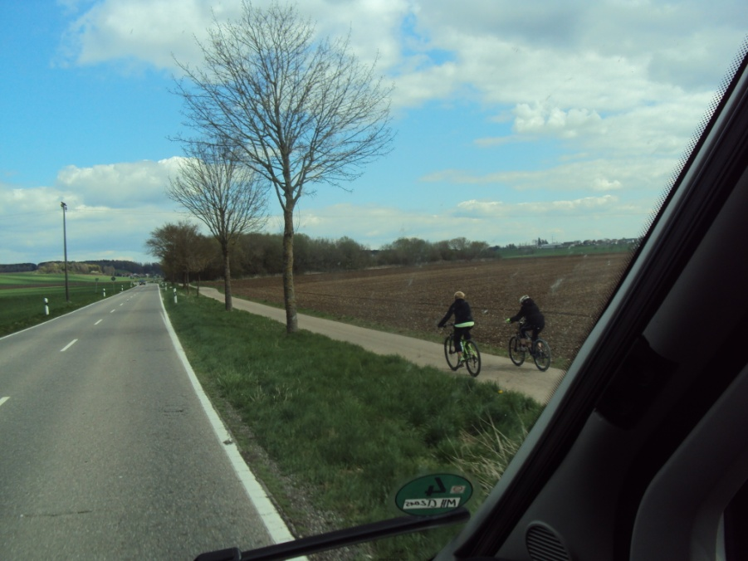
Oregon bicycle pedestrian plan.
Page 133: D.1.a. Width - 3 m (10 ft) is the standard width for a two-way multi-use path ... The minimum width is 2.4 m (8 ft). However, 2.4 m wide multi-use paths are not recommended

Copenhagen Guidelines for the Design of Road Projects
Page 8: The minimum width of a two-way cycle track in Copenhagen is 3.5 m if it is part of the PLUS net, otherwise not less than 2.5 m (one of the few stated norms in the Road Standards).

Photo: Example from southern Germany

Submission (II) – please add Newstead map
Include gully walkway that runs from the Newstead School on SH26 through to Vaile Rd
Include multi-usepath from city along-side Ruakura Rd / Morrinsville Rd to Newstead primary school

Reason:
* Employment area corner Ruakura Rd is one on largest in the Waikato.
* Good number of students at Newstead school, are children from people working at corner Ruakura/SH26, having the option of walking / cycling reduce the risk of motor vehicle crashes outside school gate, from right turn movements out of School gate.
* Many more people visit Hamilton cemetery than stay there, having the option of walking / cycling reduce the risk of motor vehicle crashes from right turn movements in/out of Cemetery entrance.

References:
One Community Plan for Eureka-Matangi-Newstead & Tauwhare 2013-2023
Page 32: Most employees of these organisations live in Hamilton ... The area is close to the Waikato University which could give residents access to their facilities, such as the library and swimming pool ... There are significant commercial activities in the area
Page 34: Roads need to be widened to allow for cycleways and walkways
Waikato District Newstead Community Plan 2004
Page 7: Road need to be widened to allow for cycle ways and walkways
Page 8: To establish safe cycle ways from the Newstead area that link with like cycle-ways in the city
Page 9: gully walkway that runs from the Newstead School on SH26 through to Vaile Rd

Submission (II) – please Added access route in Mangaonua Gully (between Cherry Lane & Matangi Rd)
4.31 Tamahere. Page 60:
NZTA is building a path in Gully linking Cherry Lane & Matangi Rd as part of Hamilton Bypass. You could save them and the council rate payer money by leaving it in place. Present plan is to spend money on removing path at end of project.

END

