 16th November 2015
From: -
Name and organisation:- Peter Bos, Rob Davidson and Melvan Driscoll (on behalf of Cycle Action Waikato)
Contact address: - P. O. Box 19-251, Hamilton. Postcode 3244. Email: - cawaikato@can.org.nz

To: - Katherine Johns Hamilton City Council
CAW Western Rail Trail – consultation Notes

Main points
- Lake Rd crossing. We Support an underpass provided it also has one long ramp to provide the essential commuting connection to Frankton, or alternatively we support two long ramps with an at=grade crossing. The ramps must be of the highest quality (14:1 gradient for wheelchairs and cycling).
- Innes Common / Hockey area is destination/place - Quality 3m paths should radiate from this place – e.g. to Lake Domain, Mary St, Queens Ave, Killarney Rd and Kahikatea Dr.
- Seddon Rd crossing, support at grade crossing. This is also supported by Living Streets Hamilton, Generation Zero, CCS disability.

First - we need to clarify the different types of cyclist.
- Children and novices. The highest priority is ensuring a safe environment for those on bikes and push scooters.
- Commuter cycling - Will use the Rail Trail’s off-road paths; they are the main users of the primary cycle network.
- Biking for fitness / sport -. Their speed tends to be high for cyclist often cruising at 30km/hr on the flat and higher than 50 km/hr on downhill runs. They cycle on-road.

Design principals
* Path must be feel safe and be seen to have ‘natural surveillance’ from adjacent properties.
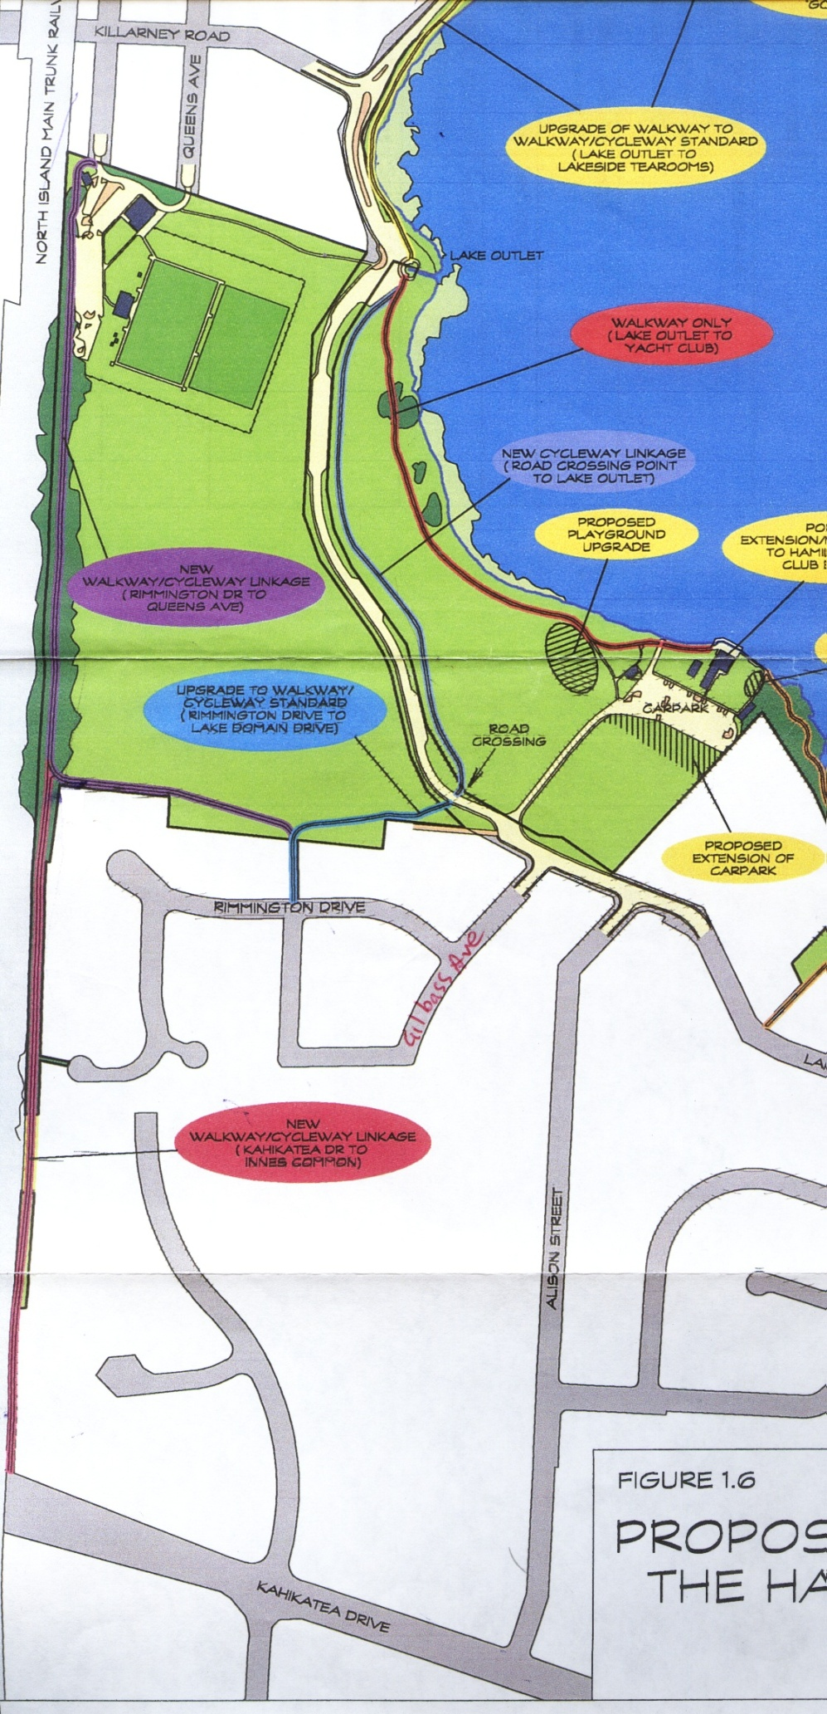
* Paths must be of suitable gradient for all types of pedestrians & wheeled pedestrians (including cyclists, mum’s with pushchairs or wheelchair users)
* Paths must have useable 2m shoulder on each side with a flush ground surface for pedestrian and cycle path runoff (for passing big groups) and to allow for future widening an absolute minimum corridor width of 6m is needed.

Comment on specific intersections
1. Kahikatea Dr entrance
(a) We are asking for route map showing quality and suitability for different type of cyclists, including Kahikatea Dr crossing within a 1 km of entrance.
2. Innes common / Hockey area is destination and place
(a) We are asking for route map showing quality and suitability for different type of cyclists, within a 1 km radius of Hockey club entrance. Map is to include information on existing plus future widening to separate walking and commuter cycling paths.
(b) Quality 3m+ paths should radiate from this place – e.g. to Lake Domain, Mary St, Queens Ave, Killarney Rd and Kahikatea Dr.
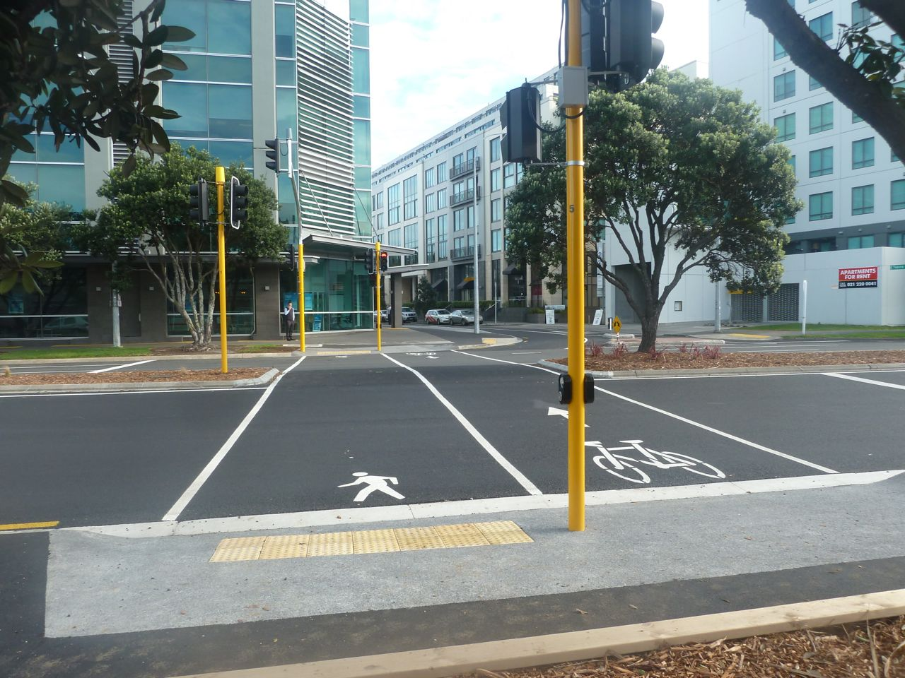
3. Killarney Rd crossing.
- providing dual (two) crossings one Pedestrian and One for bicycles would enable a significantly shorter crossing time, reducing the delay for the approx 14,000 vpd.

Having used these crossings in the Netherlands both as pedestrian & cyclist never was there confusion about where to wait or which button to press. Internationally there are many different styles, which probably explains why the design of Auckland Beach Rd ended up looking similar to pedestrian crossing.

Drawing below is my Impression of possible dual pedestrian and cycle signalized crossing.
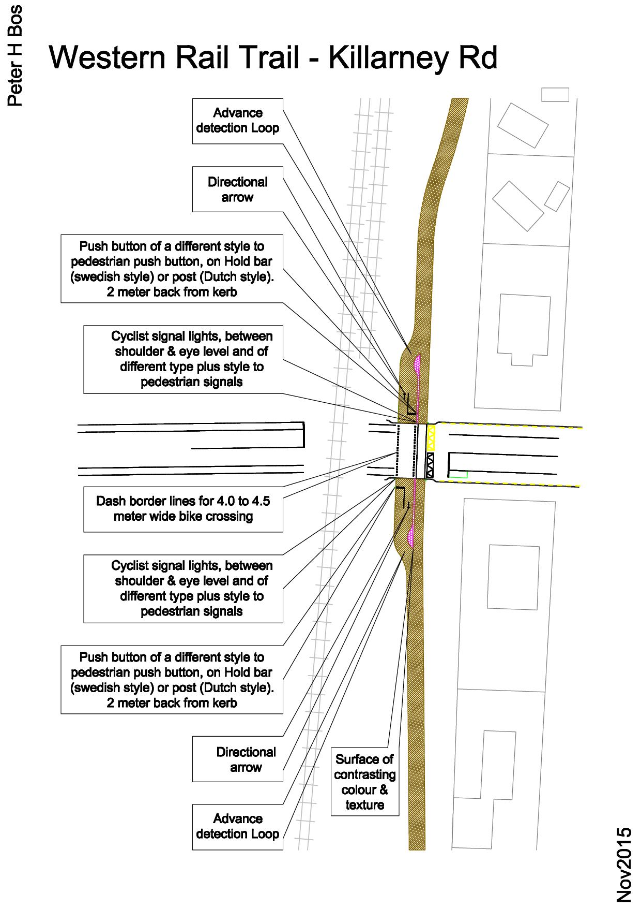
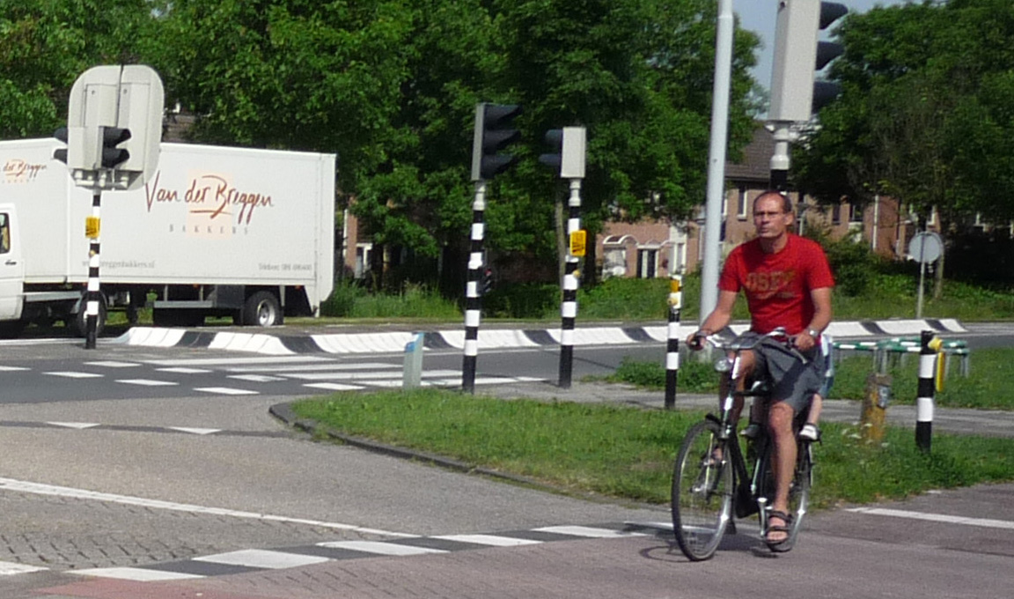
Images Netherlands & Sweden Further example from Netherlands Fietsberaad.nl Traffic lights
4. Lake Rd crossing. Most important that there is connection by two ramps to allow at-grade crossing of Lake Rd and high quality accessible & clear access to Frankton. (Must be better than merely suitable)

Comment from Melvan Driscoll in support of Lake Rd underpass.
“But if asked what is the most significant advantage of going 'under' Lake Road. it is, it totally separates motor vehicles and bicycles/wheelchairs/pedestrians - a great blessing particularly for children and the infirm who may act unpredictably or slowly in the face of traffic-light controls.
I believe the proposed crossing would be on the lower part of Lake Rd - concealed from view for motorists approaching from the Somerset St intersection - their sight-line interrupted by the 'hump' the rail bridge presents, compounded by your highlighting of the high traffic-flow on Lake Road.
I am unsure, whether this approach would be unwelcome given favouring the ramp and controlled-crossing of Lake Road.
The artist's approach of the cycle-trail 'under' Lake Road – is that which I've dreamed about for years every time I come up against the concrete impediment at the western end of the Keep Hamilton Beautiful track!”

Underpass / Tunnel design for pedestrians and cyclists.
Key statements from:
Gcm Handbook - (Gang) pedestrian, (cykel) bicycle and moped guide – Sweden
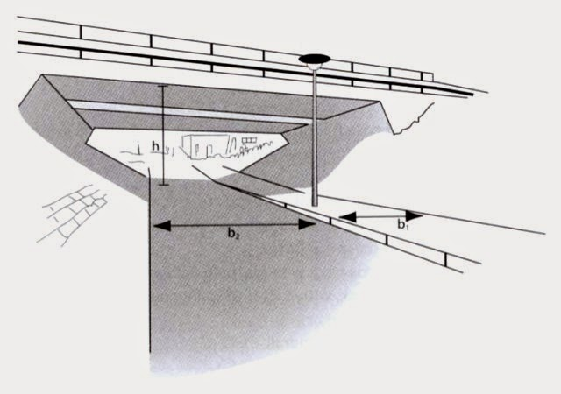
Design with sloping walls with larger tunnel width at the top ... Path should not have perpendicular connections to the tunnel ...does not lie down in "pit "... not be perceived "armoured".
Dutch C.R.O.W-design-manual-for-bicycle-traffic
Optimum visibility from the surrounding area ... minimize the length of time that a cyclist take in passing through a tunnel ... the design helps counteract any (possible) feeling of being closed-in .. A well designed cycle-tunnel: arching walls, the right width/height ratio and good use of colour.
Impression of CROW ideal tunnel. Short open, well lit, separate pedestrian path also of good width. Splayed out sides: Source - A view from the cycle path - Advice for tunnels

Further example from Netherlands - Fietsberaad.nl - Bicycle tunnel under urban intersection

NZTA urban design principles underpass
* At grade crossings are preferred by pedestrians and cyclists as they provide continuity of route, greatest visibility and perceived safety. Whenever possible, they should be chosen in preference to grade separated options.
NZTA pedestrian planning guide – 15.14 Grade separation page 15-22
Pedestrians should ideally stay at the same grade when crossing, or have only a minor change in level – if necessary, the road should be elevated ... In planning for new areas where a grade-separated crossing is required, it may be possible to utilise the terrain to achieve this.
Photo 15.14 - Underpass, Pukete, Hamilton (Photo: Tim Hughes)

C.R.O.W-design-manual-for-bicycle-traffic – Preface “The design manual is not a recipe book”
4.6.2 Tunnels versus bridge (page121)
From the point of view of sense of social safety, however, a tunnel can have some disadvantages in comparison to a bridge, because what happens in a tunnel is not visible from all sides. In addition, people may suffer from claustrophobic experiences in a tunnel (fear of closed spaces), especially when the tunnel is ... narrow.
4.6.3 Socially safe tunnel solutions (page 122)
Considering the question of what is socially safe does not just mean looking at objective, but also subjective social safety. The fact there is no crime in an area (objective) does not necessarily mean that it is perceived as being safe (subjective). It is just as undesirable that people avoid a tunnel or bridge, or only uses them reluctantly due to sense of fear evoked by such constructions

When designing a socially safe, bicycle-friendly tunnel the following premises should be employed
- That there is optimum visibility from the surrounding area
- That it lets lots of natural light in
- That the design minimize the length of time that a cyclist take in passing through a tunnel
- That the design helps counteract any (possible) feeling of being closed-in.

A well designed cycle-tunnel: arching walls, the right width/height ratio and good use of colour.

Gcm Handbook - (Gang) pedestrian, (cykel) bicycle and moped guide – Sweden
Traffic segregation – page 111
Traffic segregation built often for creating traffic crossing points, on paper is seen as a natural solution, but can sometimes be an expensive and not entirely satisfactory solution.
Security -
... no one should be surprised by other road users or “thugs", no dead angles should occur. Walls and ceilings should be bright. The tunnel section should be as open as possible; a design with sloping walls with larger tunnel width at the top gives a more open and brighter impression than the walls forming straight shafts on the sides. The tunnel should be wider than Gcm path .... Surfaces should be so smooth ... Connecting Gcm roads to the tunnel should have soft radii and visibility; they should not have perpendicular connections to the tunnel. Vegetation around the tunnel may not restrict the visibility.
Lighting in a tunnel is obviously for security experience. The contrast between the light in the tunnel and the lights of Gcm path may not become too large. The risk is that the glare occurs and the ability to detect obstacles outside the tunnel decreases. This phenomenon can create dangerous situations where vulnerable road users collide with a cyclist when they do not have time to pay attention to each other in time.
Security experience – page 134
A brightly lit underpass followed by a normal lighted walkway may thus creating feelings of insecurity when walking route probably felt as dark. Therefore walkways always need good lights where they are adjacent to a subway.
Provide a beautiful environment. Where the scale feels human and safe from perceived vandalism. The choice of lighting equipment requires it therefore to be of robust and durable materials, while acting architecturally in its environment - that may not be perceived "armoured".
The Architectural review Sep 2007
Manifesto for London |Terry Farrell
(page 70) PUT PEDESTRIANS ON TOP - Eliminate all pedestrian underpasses.
During the 1960, because of ... increase car ownership, the view was that either new or wider roads had to be built or radical reprioritisation...
... intended to produce consistent traffic flow ...
The outcome was dire. The need to keep traffic flowing continuously in order to cope with a theoretical increase in volume means that there could be no pedestrian crossings or traffic lights. The indiscriminate and sweeping response was to build pedestrian underpasses, accessed by ramps and stairs, and erect continuous railings along roads and around roundabouts to prevent ‘jaywalking’. Underpasses were/are dark and dangerous, intensely confusing for way-finding and orientation and take the pedestrian on a much longer journey.
PROPOSITION
Eliminate all pedestrian underpasses in London and replace with surface level pedestrian crossings.
Between 1995 and today the campaign to eliminate pedestrian underpasses along the east of Hyde Park is gradually bring results. - 2013 update- Planning in London - Farrell and
Transport of London replacing subways with level crossings Feb 2009

5. For Seddon road - do not support underpass – support at-grade crossing comprising: - traffic calming (table top crossing) with pedestrian-push button traffic lights & a 30km/h speed limit. (as per the Garden Place main pedestrian crossing).
Note: At grade crossing is also supported by Living Streets Hamilton, Generation Zero, and CCS disability.

No comment on car parking – see Generation Zero submission to Draft CCTP
End

