 23th Aug 2016
From: - Peter Bos ph 07 850 8835 (on behalf of Cycle Action Waikato)
Contact address: - P. O. Box 19-251, Hamilton. Postcode 3244. Email: - cawaikato@can.org.nz

To: Tony Richardson – road safety alliance – BBO
First draft - Comment on Safer roads and Roadsides Waikato Context

Main points
- Vision Zero - Life and health can never be exchanged for other benefits within the society
- Buffer strip - chevron buffer zone ... provide separation between cyclists and the traffic lane.
- Lane width - narrower cycle lanes were three to four times less safe than wider cycle lanes
Appendix
ANWB (Dutch AA) - Basic rule - The driver of the motor vehicle is liable for the accident.
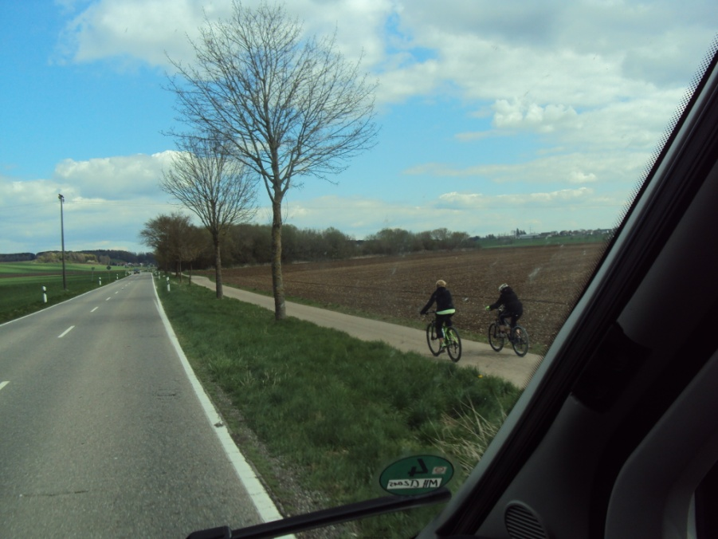
First - we need to clarify the different types of cyclist.
- Tourist, Children and novices. The highest priority is to design for weaker road users
- Commuter cycling – normally they take the most direct route
- Biking for fitness / sport - They tend to cycle on-road

- Vision Zero
Great to see Vision Zero clearly stated as benchmark of where we what to be. Along with the ‘aim to eliminate road deaths’
This is in line with Cycle panel - Safer journeys for people who cycle
P8. The Panel’s vision is ambitious, as all vision statements should be. We are aiming for ‘A safe road network with zero fatalities and reduced serious injuries for people who cycle’.

Please add to future presentations ‘Life and health can never be exchanged for other benefits within the society’

- Buffer strip
Your slide 14, ‘Improved Delineation, Rumble Strip Road marking, Widened Centre-lines’

Please change ‘Widened Centre-lines’ to ‘Widened buffer-zones’
Please include chevron buffer zone in your slide 13 ... provide separation between cyclists and the traffic lane

Safer journeys for people who cycle – Cycle panel
P18. The typical crash involves a cyclist being struck from behind on a straight road.
P34. The Panel recommends: HIGH PRIORITY ACTIONS
i. Trial mandatory minimum passing distances when drivers overtake cyclists (one metre is suggested for speed limits up to 60km/h, and 1.5 metres for speeds that are 61km/h and above).

Reference:
NSW Government - Inquiry into Vulnerable Road Users - August 2010
NRMA Motoring & Services Submission to the Parliamentary Joint Standing Committee on Road Safety (Staysafe)
http://www.mynrma.com.au/media/NRMA_Submission_to_Staysafe_Inquiry_into_Vulnerable_Road_Users.pdf
P14. Safer Motorways for Cyclists
NRMA recommends that - A minimum one metre wide buffer strip of raised profile chevron line markings within the road shoulder, immediately to the left of the carriageway edge line, to enhance safety for both vehicles and cyclists.

- Lane width

NZTA report 389: Cycle Safety: Reducing the Crash Risk - Oct 2009
P85. narrower cycle lanes were three to four times less safe than wider cycle lanes,

Safer journeys for people who cycle – Cycle panel
P18. more cyclists die on rural roads than urban ones, and rural injuries are twice as severe as those at urban speeds (70 km/h or less), with 39 % of reported injury crashes involving death or serious injury.
The typical crash involves a cyclist being struck from behind on a straight road.

NZTA pedestrian planning design guide
P112. 14.12 Shared-use paths - Ideally, keep a 1.5 m separation between the path and any adjacent roadway
P123. 2.0m minimum width for speeds over 70km/h

C.R.O.W – The Netherlands – Design manual
Table 4.3 ‘A one-way cycle-track of 2.00 m or narrower is not a good cycling-facility’

Safe System approach- ‘Acknowledges that people can make mistakes that lead to crashes’

CAW considers it immoral to design to absolute minimum widths.

Table 4.1: For a speed limit of 70 km/h, the desirable minimum width for a cycle lane and sealed shoulder is 1.9 m, while the acceptable range is 1.6-2.5 m. For a 100 km/h speed limit, the desirable minimum width is 2.5 m and the acceptable range is 2.0-2.5 m’
‘if we interpolate the lower end of the acceptable range defined by the NZ Supplement, 1.73 m would be the lower bound of the acceptable range for a sealed shoulder width for cycling where the speed limit is 80 km/h’
P28 https://wdcsitefinity.blob.core.windows.net/sitefinity-storage/docs/default-source/your-council/public-consultations/nzta---state-highway-26/evidence-of-the-requiring-authority/r-swears---transport---final.pdf?sfvrsn=2

Appendix.

ANWB – Netherlands equivalent to the AA – Translated using google
http://www.anwb.nl/rechtshulp/aanrijding-en-dan/aansprakelijkheid/voetganger-of-fietser
Pedestrian or cyclist
In a collision between a motor vehicle and a cyclist or pedestrian, the law for extra protection. Because the law the cyclist or pedestrian sees as weaker road user. Finally delivers additional risks on a motor vehicle for other traffic, by their speed and weight. How does it work in practice?
Basic rule
The driver of the motor vehicle is liable for the accident, force majeure (1. Superior or overpowering force 2. An unexpected or uncontrollable event, 3. Act of God) unless he can show. The motorist must prove that he is not guilty, which in practice is very difficult.
Cyclist/pedestrian to 14 years
In a collision between a motor vehicle and a cyclist or pedestrian under the age of 14, is the owner of the motor vehicle almost always be held accountable for any damages to the child.
Cyclist/pedestrian 14 years or older
In a collision with a vulnerable road user of at least 14 years of age, a minimum of 50% of the motor vehicle shall compensate the damage. This does not apply if the motorist force majeure. In practice, this is exceptional and very difficult to prove. This 50% is a lower limit.
Protection by law and case-law (Jurisdiction))
The legislature and the Supreme Court have chosen this to protect weaker road users extra, particularly because +motor vehicles create an additional danger by their weight and speed. Motor vehicles are also legally required to insure itself. Also in other European countries are weak in the traffic this way protected, sometimes even more far-reaching than with us.
Extra protection unjust?
For many motorists this protection of the weak sounds unfair. This would give them a free pass to violate all rules. But a cyclist will not intentionally by Red drive with the idea: "I do not have to pay the damage anyway". He will rather be guided by the risk that he ends up in the hospital. A motorist who drives by red light, that will finally also not intentionally do. Only he runs far less physical risk.

Lastly in the real world
Switzerland has been building a fully connected safe off road cycle network for over a century.
Yet you will still find the People Biking for fitness / sport in the traffic lane.
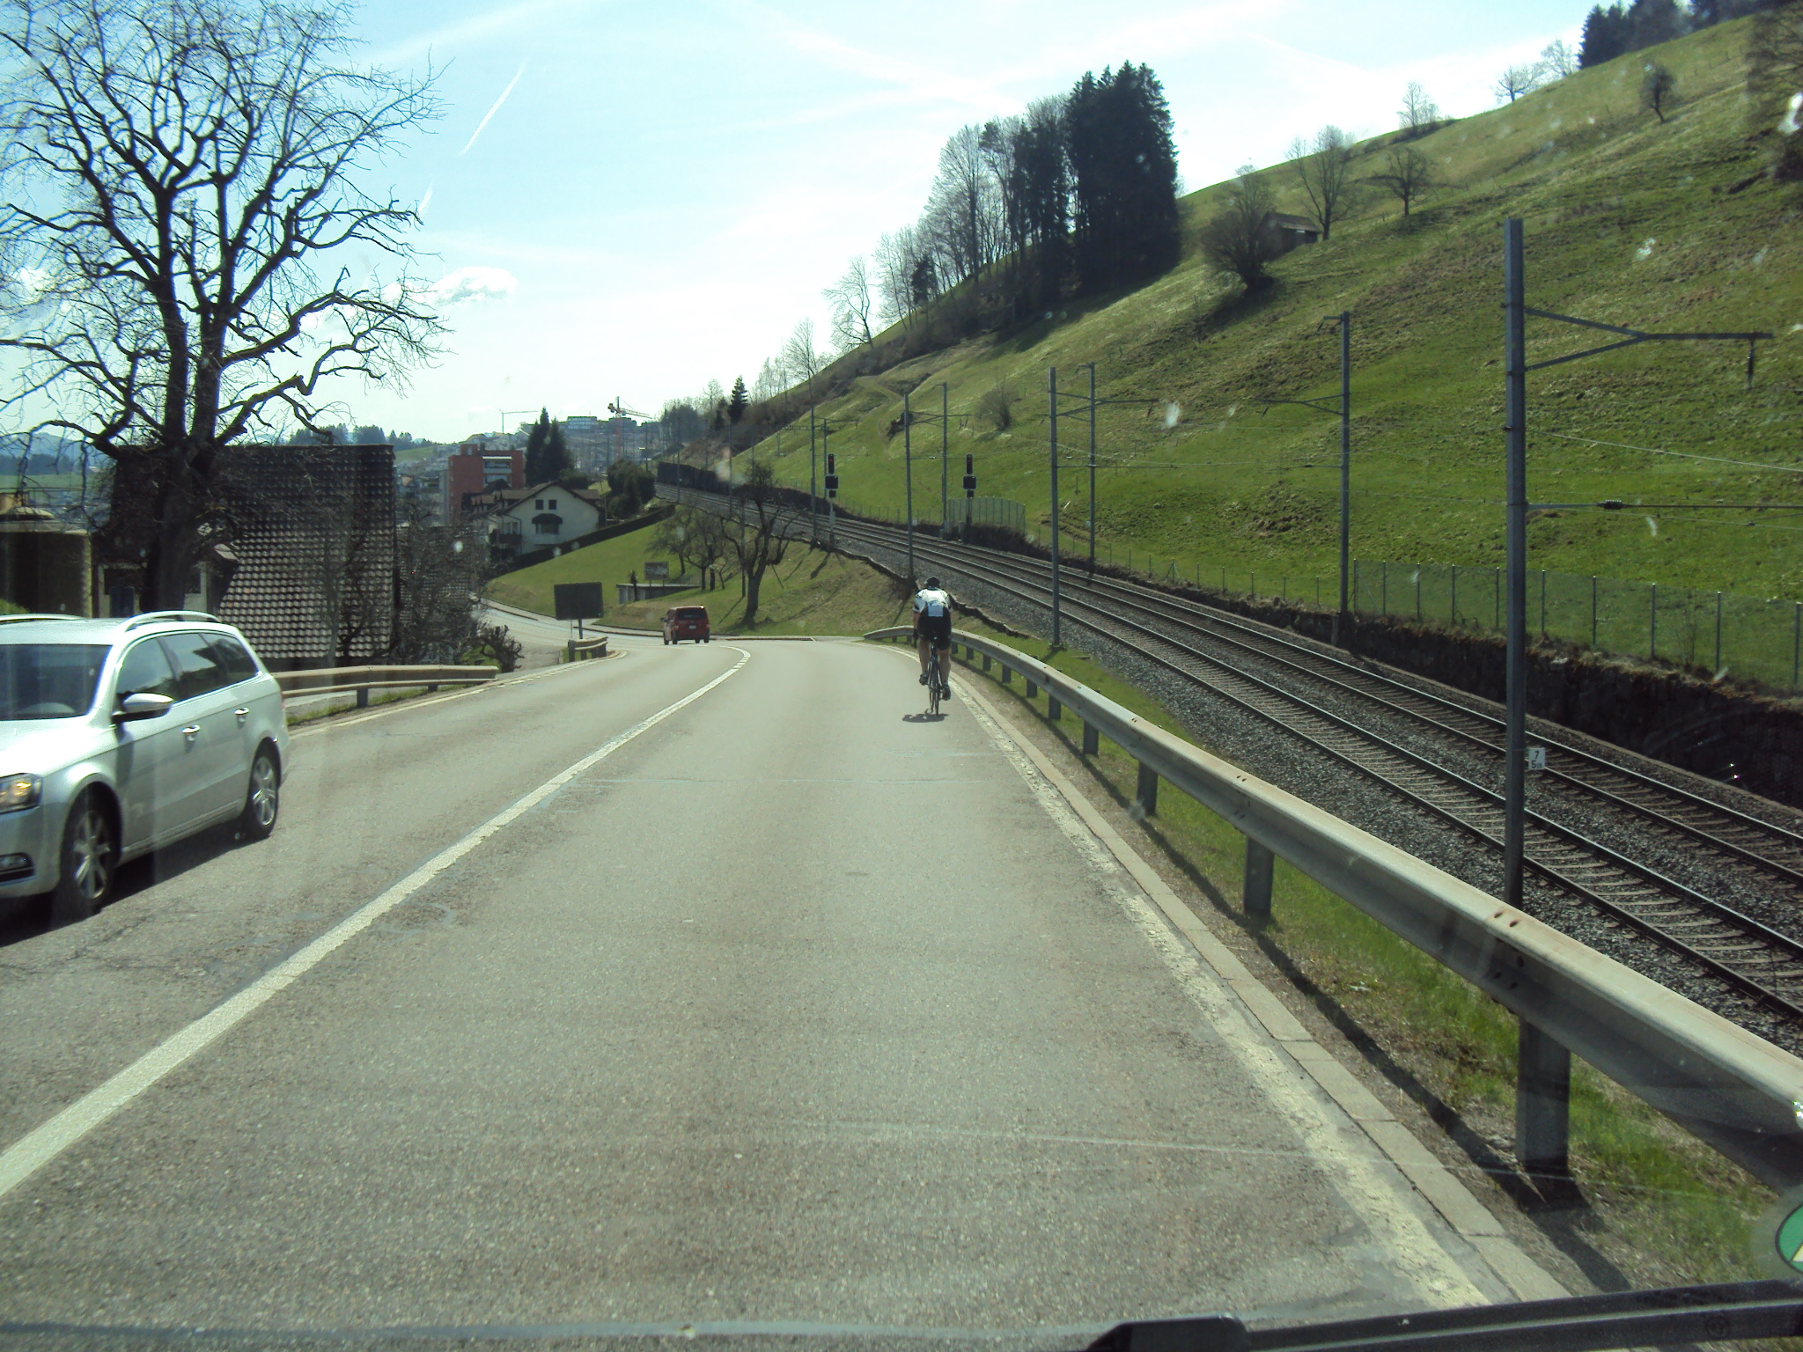
END

