 03rd Nov 2016
From: - Peter Bos ph 07 850 8835, Rob Davidson & Claire Sherrington
Contact address: - P. O. Box 19-251, Hamilton. Post code 3244. Email: - cawaikato@can.org.nz
To:
Tony Richardson – Safe Roads Alliance – BBO
Maclean Hastie – Safe Road Alliance - NZTA
Comment on Safer roads Hamilton to Whatawhata – SH23

The proposed improvements for safer motoring (wide central medians and crash barriers) will make it highly dangerous for people cycling. Can NZTA please mitigate this extra danger created by the faster and heaver road users through redesigning this project in a way that give the weaker road use greater protection.

Main points
- Support Reducing speeds
- Buffer strip - provide separation between cyclists and the faster-heaver vehicles.
- Lane width - narrower cycle lanes were three to four times less safe than wider cycle lanes
Further reading: Austroads Research Report – Cycling on Higher Speed Roads
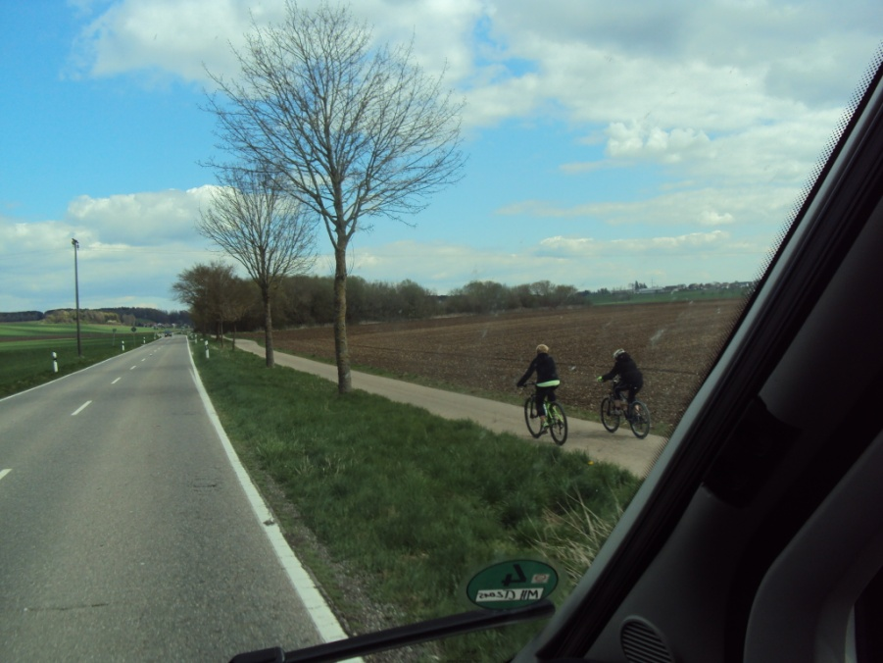
First - we need to clarify the different types of cyclist.
- Tourist, Children and novices. The highest priority is to design for weaker road users
- Commuter cycling – normally they take the most direct route
- Biking for fitness / sport - They tend to cycle on-road

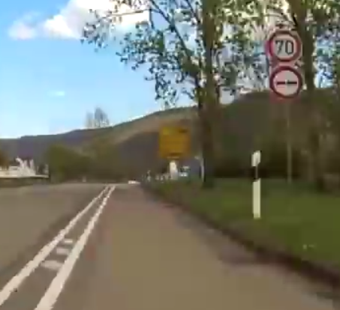
- Cycle Action Waikato supports safer speed, which are what many tourists would expect for this type of road.
Max speed 80 km/h for ‘Single carriageway’: China, Demark, Finland (winter), France (rain), India, Japan, South Korea, Taiwan.
Max speed for trucks 80kmh or less: Argentina, Brazil, Czech Republic, Denmark, Finland, Germany, Greece, Hungary, Israel, Italy, Japan, Malaysia, Netherlands, Norway, Peru, Philippines, Poland, Portugal, Singapore, Saudi Arabia, South Africa, South Korea, Spain, Sweden, Taiwan, Thailand, Turkey.
https://en.wikipedia.org/wiki/Speed_limits_by_country

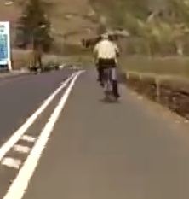
- Buffer strip – Wider buffers or flush medians
SH23 – Hamilton to Whatawhata Overview Plan
http://www.nzta.govt.nz/assets/projects/sh23-hamilton-to-raglan/SH23-Hamilton-to-Whatawhata-Overview-Plan.pdf

Please change ‘Wide Centrelines’ to ‘Widened buffer-zones’

Safer journeys for people who cycle – Cycle panel
P18. The typical crash involves a cyclist being struck from behind on a straight road.
P34. The Panel recommends: HIGH PRIORITY ACTIONS
i. Trial mandatory minimum passing distances when drivers overtake cyclists (one metre is suggested for speed limits up to 60km/h, and 1.5 metres for speeds that are 61km/h and above).

Reference:
NSW Government - Inquiry into Vulnerable Road Users - August 2010
NRMA Motoring & Services Submission to the Parliamentary Joint Standing Committee on Road Safety (Staysafe)
http://www.mynrma.com.au/media/NRMA_Submission_to_Staysafe_Inquiry_into_Vulnerable_Road_Users.pdf
P14. Safer Motorways for Cyclists
NRMA recommends that - A minimum one metre wide buffer strip of raised profile chevron line markings within the road shoulder, immediately to the left of the carriageway edge line, to enhance safety for both vehicles and cyclists.

- Lane width
NZTA report 389: Cycle Safety: Reducing the Crash Risk - Oct 2009
P85. narrower cycle lanes were three to four times less safe than wider cycle lanes,

Safer journeys for people who cycle – NZ Cycle panel
P18. more cyclists die on rural roads than urban ones, and rural injuries are twice as severe as those at urban speeds (70 km/h or less), with 39 % of reported injury crashes involving death or serious injury.
The typical crash involves a cyclist being struck from behind on a straight road.

NZTA pedestrian planning design guide
P112. 14.12 Shared-use paths - Ideally, keep a 1.5 m separation between the path and any adjacent roadway
P123. 2.0m minimum width for speeds over 70km/h

C.R.O.W – The Netherlands – Design manual
Table 4.3 ‘A one-way cycle-track of 2.00 m or narrower is not a good cycling-facility’

Sustrans Design Manual – UK - Handbook for cycle-friendly design April 2014
P16. Minimum widths for one-way cycle lanes
2.0m (or 1.5m + 0.5m margin) on busy roads or speed limit 40mph [65 km/h]

Further reading
AUSTROADS RESEARCH REPORT Cycling on Higher Speed Roads
https://www.onlinepublications.austroads.com.au/items/AP-R410-12

End

