SUBMISSION
Simplified Walking and Cycling Procedures

Dear David,
Thank you for consulting with Cycling Advocates’ Network on the proposed PEM Simplified Walking and Cycling procedures. We are delighted about the proposed changes, and we commend your ongoing support. As requested, please find some detailed feedback below. We are commenting on both the proposed PEM amendments and the framework report.

Framework for a Simplified Procedure for Evaluating Walking Projects
In section 7, it is said, “the distinction between recreational and utilitarian facilities needs to be explored.” We note that it is the trips that may be distinguished between recreational and utilitarian, but all facilities will always be experiencing a varying proportion of these two types of trips. It is pointed out in the report that the simplicity of the procedure is no longer secure, and we concur with that statement.
Whilst some road controlling authorities are known to differentiate between school children and non-school children when manually counting cyclists, none (to our knowledge) are differentiating between utilitarian and recreational users. Simplicity is indeed lost when the required data are not readily available. And whilst it may be relatively straightforward differentiating between school children and non-school children, it’s almost practically impossible in many cases to determine the utilitarian/recreational split of trips (do you base it on what they “look” like?). It’s made more difficult by the fact that many trips combine both purposes, e.g. a person could choose to cycle or walk for transport purposes to a location because it happens to be a nice day and they’d like to enjoy their trip as well.
The proposed procedure and evaluation is based on many assumptions, as is appropriate for simplified procedures, especially when new areas of knowledge are explored. For example, whilst recreational trips might be assessed at only 40% of the rate of utilitarian trips, it is suggested that the average recreational trip is 2.5 times as long, conveniently arriving at the same benefits for the total trip lengths.
A different assumption that could be made is that recreational trips indeed generate benefits including congestion relief, travel time, operating cost and environmental costs. It could be argued that the alternative to making a recreational ride or walk is to drive to the gym and exercise there. This very much reflects common behaviour in New Zealand.
The advantage of this suggested methodology is that a distinction between utilitarian and recreational trips becomes redundant, simplifying the procedure in accordance with the spirit of this part of the Project Evaluation Manual, but still giving a true reflection of the situation.
We also note that other simplified procedures do not differentiate between different vehicle types, but composite values are given, enabling a simplified evaluation. When the full procedures must be applied, e.g. because the project is above a certain value, the more specific evaluation may be required. A similar approach could be chosen for walking and cycling projects, and we suggest that composite values should be available for all simplified procedures.

SIMPLIFIED PROCEDURE No. 6 – WALKING AND CYCLING PROJECTS

Introduction
The first sentence should read “…with the exception of signalised cycling and pedestrian crossings over roads.”
In the third paragraph, it is stated, ”In particular, where a separate dedicated cycleway is proposed the alternative option of providing wider sealed shoulders or cycle lanes on the carriageway must be considered.” Whilst we totally support that land transport funds must be spent wisely, we would like to compare this to the analogy discussed in section two of the framework report. There, it is pointed out that the benefits for various measures are deemed to be the same for a given number of pedestrians, implying that the cheaper the measure, the higher the BCR, which is obviously often not the case. The example was illustrated by comparing the signposting of a site with the installation of a signalised pedestrian crossing. Obviously, the benefits of these two measures are completely different, however, the given methodology does not enable to calculate this difference.
Coming back to the dedicated cycleway and the impetus that cycle lanes must also be considered, it is in our opinion not sufficient to require an incremental BCR on the difference in construction costs only, as no analysis tools are given for a differential analysis of the benefits. We therefore suggest that additional guidance must be sought when making a decision between these fundamentally different project options.
Figure 1 is from the CAN submission on the Cycling Design Guide as a replacement for the more complex facility decision-making flow chart.
It can be seen that above certain speeds and volumes, a path treatment is preferable to cycle lanes or (widened) sealed shoulders. With the PEM guidance as it is suggested, a more expensive path would not qualify over a cycle lane, even if this were supported by the above graphic.
CAN is unsure why it is stated that most cycling projects will be linear facilities, and we are not convinced that this should be stated here.
There are many projects that are not linear projects. Signage of cycle routes on quiet local roads (i.e. no specific cycle facilities), railway crossings, bridges, subways, property purchase to enable strategic cycle links, especially away from roads, traffic signals or other special facilities for cyclists at intersections, improvements to accessing paths (e.g. kerb ramps, removing barriers), removal of “pinch points” on roads or bridges for cyclist safety, traffic calming projects where cyclists are an identified user group, facilities to help cyclists use public transport (e.g. cycle racks on buses and trains), public cycle parking facilities, and rest facilities for cycle tourists are all non-linear projects that could attract Transfund subsidy. One consequence of the statement as it stands could be that RCA’s may get the impression that Transfund expects applications for linear projects only.
Somehow recreational walkers are only concerned with new paths, while utility walkers are only concerned with road crossings. These generalisations should be taken out and the procedures made as non-assuming as possible.
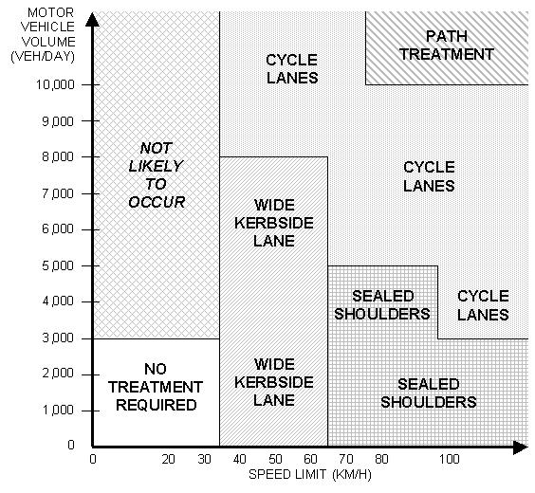
Figure 1: Facility Selection Tool

Worksheet 1
Under “User Data”, all sorts of nice quantitative info like Estimated motor veh speed (shouldn’t this be before & after, as it may change with some projects?) and widths before/after are collected. To our knowledge, this data is not much use though, as it doesn’t get fed into anything and we doubt that qualitatively it would make or break approval for a project. It would be nice if this info could actually be used to quantify some specific benefits. E.g. additional safety benefits/km for every 5km/h reduction in traffic speeds, additional comfort / reduced frustration benefits for every additional 0.25m of path width provided.
It may also be beneficial to undertake more research in these areas.

Worksheet 3
The heading should read “Walking and Cycling Projects”.
Note 3 talks about periodic reseals and the corresponding table lists this as the one possible item. It may be advisable to make this note and table more cycle-project specific, e.g. by including reapplying coloured surfacing.

Worksheet 4
The heading should read “increased” rather than “increases”.
We feel that more guidance should be given about the distinction between applying a benefit over the length of a new facility vs applying it over the length of a whole trip where a hazardous location is treated. What if the hazardous location is a LENGTH of road? Do you apply the benefit to the length treated or to the trip length? Wouldn’t most projects (linear or isolated) generally be removing some kind of existing hazard or discomfort? We think some clarification in the notes is needed on this, and maybe even further consideration about how this might work in practice.

Regards,

Axel Wilke
(CAN Technical Adviser)
for CAN
PO Box 6491; Wellesley St; Auckland
E-mail: secretary@can.org.nz
Website: www.can.org.nz
The Cycling Advocates' Network of NZ (CAN) Inc is this country's national network of cycling advocate groups. It is a voice for all cyclists - recreational, commuter and touring. We work with central government and local authorities, on behalf of cyclists, for a better cycling environment. We have affiliated groups and individual members throughout the country, and links with overseas cycling organisations. In addition, several national/regional/local government authorities, transportation consultancies, and cycle industry businesses are supporting organisations.

