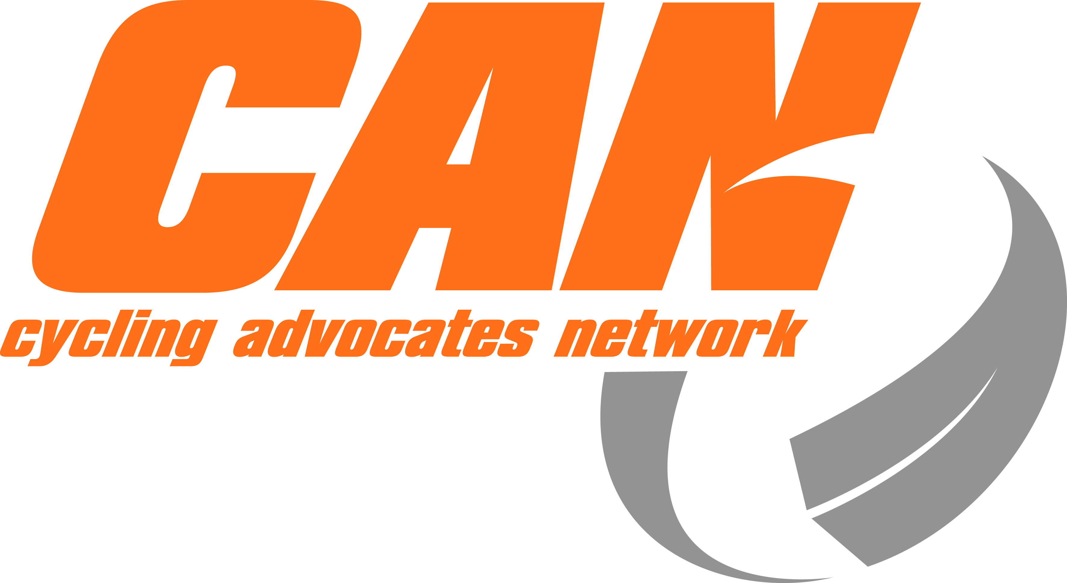
CAN Do - Whanganui 5-6 April 2014 – Building Community
Registration Form - send to patrick@can.org.nz
Are you passionate about more people on bikes, more often?
Celebrate cycling. Network with others and discover today’s most effective tools for change.
We'll have expert panel discussions and workshops designed to inspire and inform.
Venue: Quaker Settlement 76 Virginia Road, Whanganui
Name
Address
Phone and mobile
Email
Organisation
I will be attending: | Please Tick or Circle | Cost
Saturday only |  | $60
Sunday only |  | $60
Both Saturday and Sunday |  | $100
Late registration fee  (after 31 March) |  | $20.00
I will be attending the meal on Saturday night | Yes / No | Included in registration fee
Please indicate if you have any special dietary requirements
TOTAL (includes breakfast, lunch and dinner on Saturday; breakfast and lunch on Sunday) |  | $
The venue is open from 2pm on Friday 4 April, so come early if you can.
Payment: Electronic payments to Cycling Advocates' Network, Kiwibank, 38-9005-0922435-01 Please reference your name and CAN Do. Alternatively, make cheques payable to Cycling Advocates Network, and post to CAN Do, PO Box 25-424, Wellington 6041.
Travel: If required, CAN can provide travel subsidies for cycling advocates. Applications should be made separately to CAN (patrick@can.org.nz).
Accommodation: At the venue, Quaker Settlement Whanganui. Own arrangement and cost. There's a range of options from bunkroom to motel. Refer to CAN website or Facebook for details.
Bike Hire: We recommend you bring or hire a bike. Refer to CAN website or Facebook for details.
Contact: Patrick Morgan on Tel: 04 210 4967 / 027 563 4733, patrick@can.org.nz
Whanganui contact is Lyneke Onderwater, lyneke@orcon.net.nz, tel 021 268 2052
Stay connected @ www.facebook.com/CanDo2014

Programme and more info: http://can.org.nz/cando2014
See you there, Lyneke, Patrick and the CAN Committee 03 March 2014

