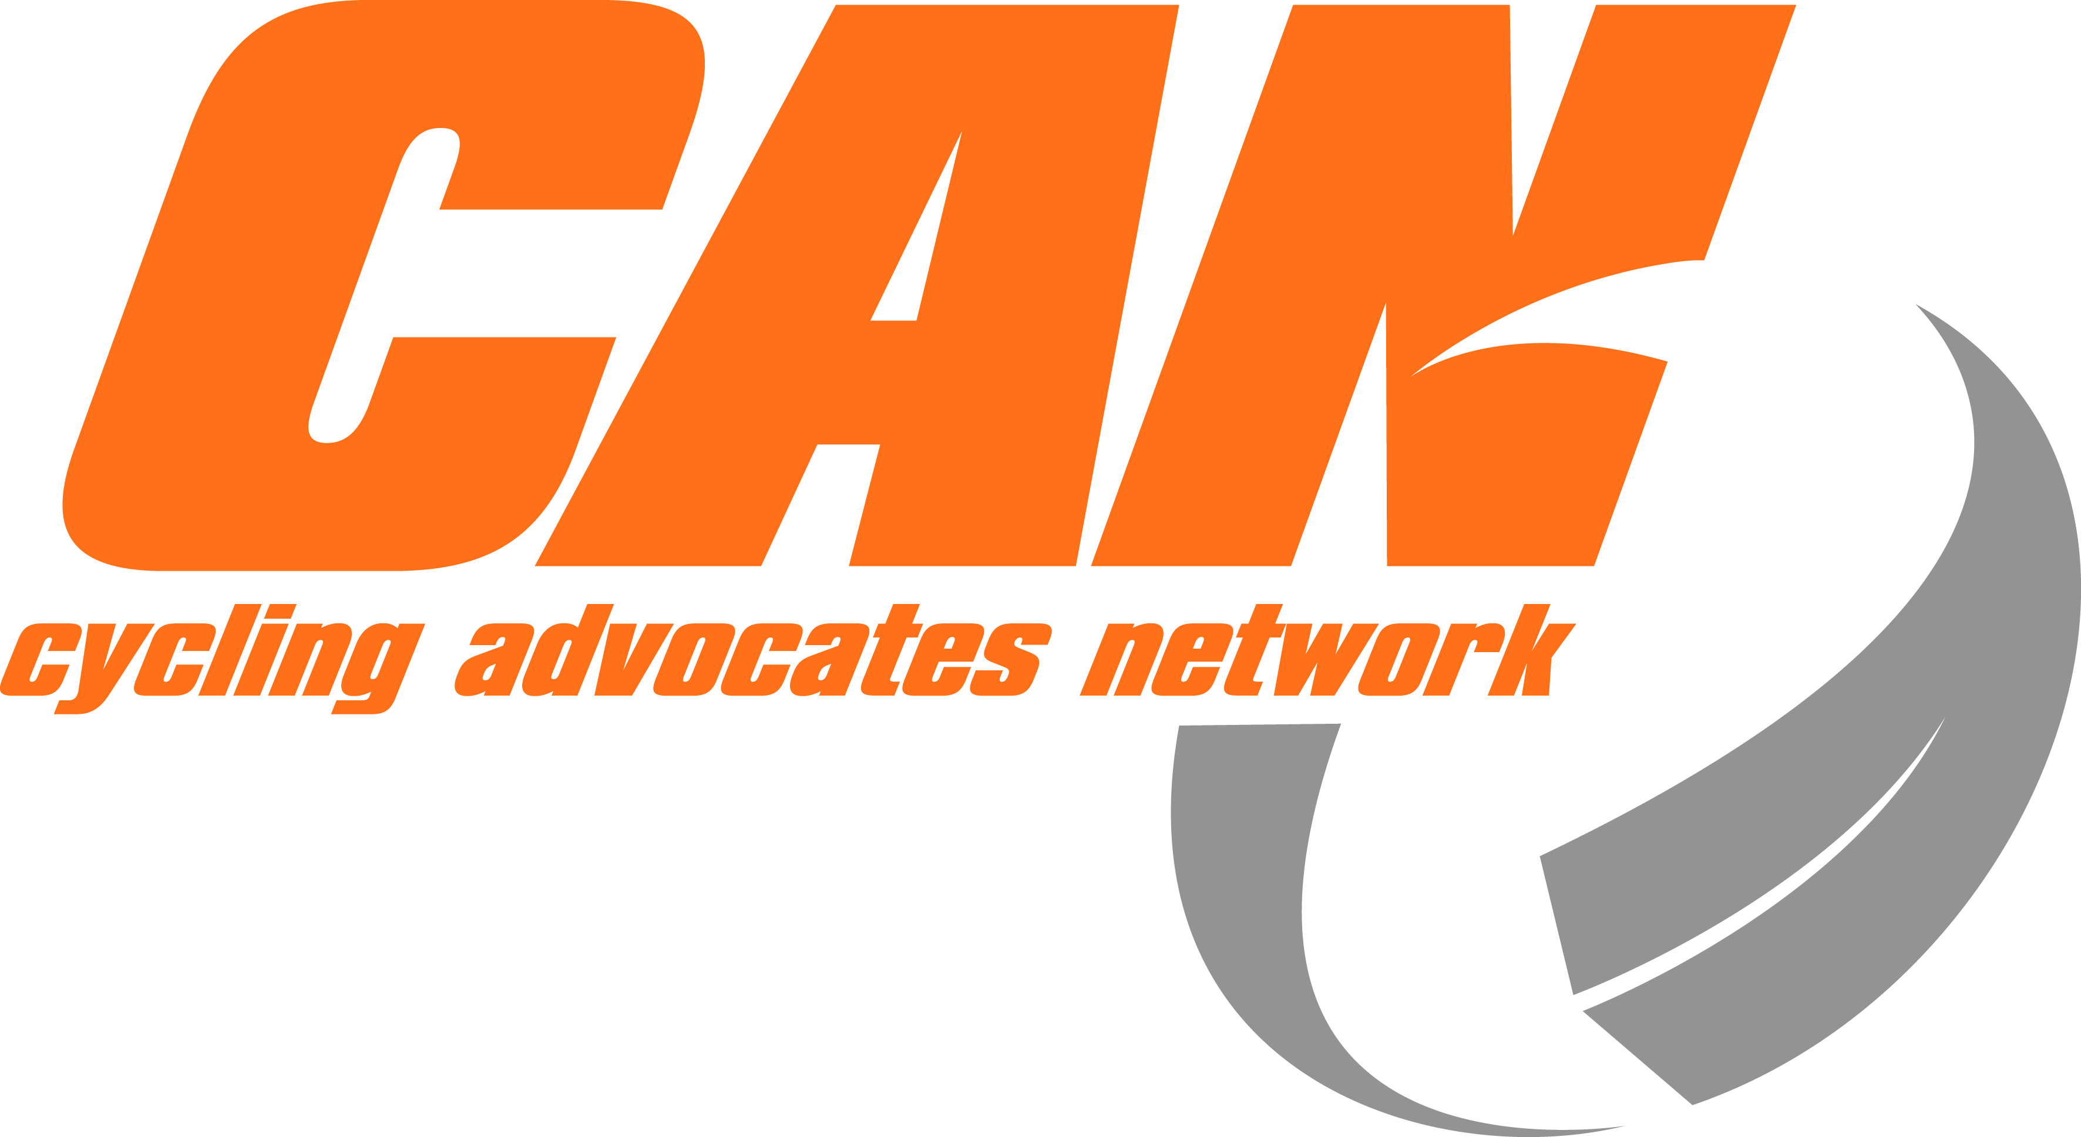
CAN Do - Auckland 13-14 April 2013 - Inspiring Change
Registration Form
Are you passionate about more people on bikes, more often?
Celebrate cycling. Network with others. And discover today’s most effective tools for change.
We'll have expert panel discussions and workshops designed to inspire and inform.
Name
Address
Phone and mobile
Email
Organisation
I will be attending: | Please Tick or Circle | Cost
Saturday only |  | $60
Sunday only |  | $60
Both Saturday and Sunday |  | $100
Late registration fee  (after 31 March) |  | $15.00
I will be attending the meal on Saturday night | Yes / No | Included in registration fee
Please indicate if you have any special dietary requirements
TOTAL (includes breakfast, lunch and dinner on Saturday; breakfast and lunch on Sunday) |  | $
The venue is open from noon on Friday 12 April, so come early.
Payment Electronic payments to Cycling Advocates' Network, Kiwibank, 38-9005-0922435-01 Please reference your name and CAN Do. Alternatively, make cheques payable to Cycling Advocates Network, and post to CAN Do, PO Box 25-424, Wellington 6041
Travel If required, CAN can provide travel subsidies for cycling advocates. Applications should be made separately to CAN (patrick@can.org.nz).
Accommodation Own arrangement and cost. Refer to CAN website or Facebook for details.
Bike Hire We recommend you bring or hire a bike. Refer to CAN website or Facebook for details.
Contact Patrick Morgan on Tel: 04 210 4967 / 027 563 4733, patrick@can.org.nz
Auckland contact is Barb Insull, barbarainsull@gmail.com, tel 027 473 1831 / 09 377 4047
Stay connected @www.facebook.com/CanDo2013

Programme and more info http://can.org.nz/cando2013
See you there, Barb, Patrick, and the CAN Exec 14 March 2013

