

Press Release (Embargoed until Jan 14, 6am) July 28, 2026

Iconic design sought for Auckland Harbour Bridge’s Pathway

Prominent Auckland architects, Copeland Associates, have been commissioned to create an iconic design for the Pathway proposed for the Auckland Harbour Bridge and Aucklanders are being invited to have their say.

GetAcross spokesperson Bevan Woodward says “Following NZTA’s agreement to the feasibility of the Pathway on the city-side of the Auckland Harbour Bridge, the concept design work can commence.”

“We’re after an iconic design with the ‘wow!’ factor. We want to create a top 10 tourist attraction for the Auckland region and an asset all Aucklanders will be proud of.”

“Hence we’re inviting Aucklanders to have their say on the Pathway’s design. They can do this by completing the online survey at www.getacross.org.nz.”

Copeland Associates director, Barry Copeland says “This is a waterfront project that ticks all the boxes for us. It requires innovative design thinking to allow access to New Zealand’s most iconic bridge for all Aucklanders and visitors to our city. From an environmental, health, tourism and urban perspective, it is a winner.”
Bevan Woodward says “We’re excited to have Copeland Associates working on the design. They have great experience in this type of project and we’re eager to see what they come up with.”

Concept designs are expected to be made public in February. The Auckland Harbour Bridge Pathway project is working to a completion deadline in time for the Rugby World Cup.
ENDS
A copy of the survey is provided on the following page.
Media Contacts…
Bevan Woodward 021 122 6040 www.getacross.org.nz

Barry Copeland, Director
Copeland Associates 09 522 5259 www.copelandassociates.co.nz

SURVEY (online at www.getacross.org.nz and to be e-mailed to 11,000 GetAcross supporters)

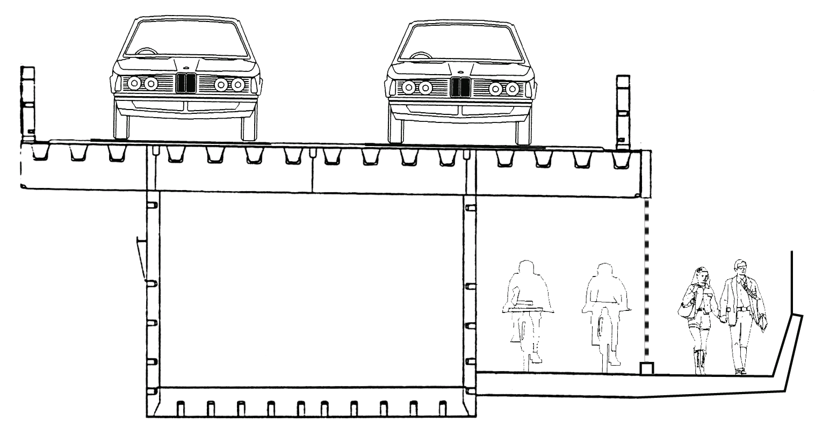

The city-side clip-on of the Auckland Harbour Bridge has ample capacity for a two-way walking and cycling pathway as indicated in the diagram above.

NZTA have agreed to the initial feasibility and we have commissioned Auckland architects, Copeland Associates, to work on an iconic design for the Pathway.

Your views will help us in the design process:

1) Should the Pathway be fully enclosed from the weather or partially open?

2) It is proposed that the Pathway will be well lit at night, have security staff, and viewing stations that will include seating, drinking fountains and coin-operated binoculars. Is there anything else you’d like to see?

3) As a possible user, what would be your main concerns about using the Pathway?

4) To reduce security costs and allow maintenance access, we may need to close the Pathway at night, eg: from 11pm until 6am each weekday. Would this be of concern to you?

5) Can you refer us to any walking and cycling bridges that might inspire our design?

6) Is there a design theme you’d like to suggest? Or anything else you’d like to comment on?

Please e-mail questions@getacross.org.z with any other questions or suggested design material.

Frequently Asked Questions about the Proposal for a tolled Pathway on the AHB.

Will the majority of the toll be consumed by collection costs?
No, only about 9% of the toll is used to pay for its collection, the rest of the toll goes to debt repayment, maintenance, security, insurance, operations and administration. The tolling system is based on public transport fare collection technology that provides patrons with a wide range of payment options whilst minimizing the transaction cost.

Why should walkers and cyclists pay when motorists don’t?
Ideally there would be no toll for walking and cycling access, but the reality is that the Pathway is highly unlikely to happen within the next 25 years without such a toll as the NZTA do not regard it as a funding priority. Motorists paid a toll to use the Auckland Harbour Bridge for 25 years, from 1959 until 1984.

What about the clip-on’s ability to carry the loading?
The eastern (south-bound) clip-on has ample capacity, as detailed by Beca’s September 2009 analysis. The tolling system’s control gates can be used to monitor the number of people using the Bridge to ensure extreme live loads cannot occur.

Has this option for a Pathway under the deck been considered previously?
Yes, this option was explored by Beca in their Feasibility Report (see diagram below) and in the Maunsell access study, but was disregarded early as “Security was found to be a defining issue”. However, by tolling the Pathway, a high level of security is funded to ensure user safety, and the toll itself has some security benefits (reducing the likelihood of loitering).

Is it a priority for the region?
Yes, the walk/cycle way not only fixes most the most significant gap in Auckland’s walking and cycling network, it is a cornerstone project for improving walking and cycling in the Auckland region - similar to Britomart Station being the cornerstone project for the revival of Auckland’s once dreadful rail passenger service.

Currently Auckland has the reputation of being one of the worst cities in the world for walking (pg 28, ARTA’s Sustainable Transport Plan 2006-16) and only 1% of Aucklanders regard cycling as “always safe” (ARC’s Community Perceptions Report 2007).

Do Aucklanders want it?
Yes, in November 2007 Y&R commissioned market research to gauge the level of support amongst Aucklanders for the walkway and cycleway. Very strong support was revealed, with 76% in support, 12% against and 12% unsure. See the survey results at: www.caa.org.nz/AHB/Support/MarketResearch.pdf

Aren’t the clip-ons too unstable for a walkway and cycleway?’
The clip-ons are currently undergoing major strengthening, which includes the addition of 700 tonnes of steel at an estimated cost of $45 million. This strengthening will reduce movement, making the walk/cycleway safe and comfortable:

"Through innovative thinking, further structural elements have been incorporated into the current strengthening works at relatively low cost to future proof for future walking and cycling options on the box girders [clip-ons]."
May 2008 Board Transit Paper 6189
www.caa.org.nz/AHB/Comms/TransitBdPaper6189.pdf

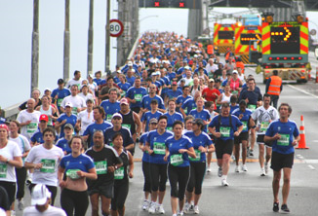
Isn’t it too steep to walk or cycle over the Auckland Harbour Bridge?
The gradient of the Bridge is 3 degrees (5%). This is considered a gentle grade and rated “easy” by the National Cycleway guidelines.

Will the Pathway affect the flow of traffic across the Bridge?
No, the shared Pathway is under the traffic deck and does not affect the configuration of traffic lanes in any way.
7,500 Marathon runners run over the Auckland Harbour Bridge in November each year

Why not wait until the next harbour crossing, or use racks on the front of buses to carry bikes?
The Transport Agency’s Waitematā Next Harbour Crossing Study 2008 determined the next harbour crossing shall be a tunnel for vehicles, with walking and cycling access to be provided on the existing Auckland Harbour Bridge. However, waiting for the harbour road tunnel to be built means waiting 25 years or more for walking and cycling access across the harbour.

Putting bikes on buses to cross the Bridge is not a satisfactory option, as cyclists enjoy cycling for fitness and convenience, and don’t want the delays and financial cost of taking a bus. A bus fitted with a rack can carry a maximum of 3 bicycles at time, thus it is not appropriate for the estimated demand of 600 to 1,500 cyclists per day.

Cyclists currently use ferries to cross the harbour; however the demand is now exceeding capacity at peak times, hence Fullers Ferries support walking and cycling access on the Auckland Harbour Bridge.

What about the proposed “ANZAC” Bridge?
The ANZAC Bridge has been suggested to replace the existing Auckland Harbour Bridge and do away with the need for a tunnel. It would run through the Wynyard Quarter development across the harbour to the Onewa Rd/SH1 interchange.

Whilst the ANZAC Bridge proposal has some merit, its impact on the Wynyard Quarter waterfront is severe; reducing the likelihood it will be built. Furthermore, the existing Auckland Harbour Bridge has a long economic life expectancy, and the demand for future roading capacity across the Waitematā Harbour should first be met with the public transport tunnel, and the transfer of road freight to coastal shipping and rail freight services.

